**PART B**

**Aim of The Project:**  Micro-Project on data analysis on trending topics

**Brief description**: -

* A trending topic is a subject that experiences a surge in popularity on one or more time. Trending topics often evolve around popular cultural occurrences such as current events, celebrity announcements, TV premiers, social concerns, breaking news and viral content.
* There’s no limit to how long a topic stays popular, though trending topics tend to have a shelf-life of one day to one week.
* Trending topics are determined by algorithms created by the site on which the topic appears. Trending topics often come in the form of hashtags, but they can also be simple keywords that have been frequently used on social media.
* Ecommerce businesses can check social media trends to find out what’s holding consumer interest and capitalize on the current conversation.

**Aim** **of Micro-Project: -**

The Micro-Project Aims To: -

* Compare keywords entered.
* Find top trending topics by country.
* Find Keyword related topics and queries.

**Course Outcome Integrated:**

1. Perform operation on data structures in Python
2. Handle Exception
3. Design classes and function for given problem.

**Actual Procedure Followed:**

1. **Group Formation:** -PWP Is A Subject That Teaches Us Some Important Concept About python language. Language constructs as well as its object-oriented approach aim to help programmers write clear, logical code for small and large-scale projects. The Basic Aim Of Micro- Project Is To Accelerate The Attainment Of The Various Outcome In The Course. In The First 2 Weeks Of April The Subject Was Introduced. The Syllabus As Well As Detail Of Micro-Project Was Discussed. The Group Of 10 Members Was Formed And The Group Leaders Were Selected. The Schedule Of Plan “A”,” B” & “PRESENTATION OF MICRO-PROJECT” Were Finalized. The Various Micro-Project Topics Related To Subject Were Discussed Our Guide Gave Us The Opportunity To Select The Topic Of Our Choice.
2. **Finalization of Micro-Project: -** After Attending The Lectures For 2 Weeks. We Selected The Topic For Micro-Project. We Discussed The Topic With Our Guide Regarding The Concept Which We Are Going To Apply In The Project. We Individually Tried To Explain The Basic Platform Of Project.
3. **Planning: -** After Finalization Of The Project We Started Working On The Project. We Started The Planning Phase. We Discussed Among Ourselves Regarding The Resources Such As Testing Material, Software Requirements, Etc. In This Week We Completed ‘PART A PLAN’ Of The Micro-Project Which Is Nothing But An Initial Description About The Project. We Submitted It To The Guide.
4. **Module Distribution &Analysis Part: -** Once The Planning Was Over Regarding Resources, Etc. We Finalized The Module Which. We Will Be Testing. According To Members We Distributed The Module. We Started The Analysis Of Project.
5. **Design Part: -** In This Part We planned & Focused on Designing the user interface of the application. We tried to give a User-Friendly look to it.
6. **Implementation: -** In This Week We Actually Started The Technical Phase. In This Phase We Technically Applied The Formatting As Decided. Each Member Was Designing project modules Which Was Assigned To Them. Finally, The Project Was Within The Schedule Time.
7. **Presentation: -** In This Week We Had To Present The Micro-Project . Each Member Of Group Presented Their Own Parts With Confidence In Front Of Guide. She Asked Us Various Queries Regarding The Topics. We Explained Her About The Various Components Of the project. She Asked Us To Do Some Changes Regarding Some Topics.
8. **Submission: -** This Week Was Submission Week. We Submitted Our Project Along With ‘Part A & B Plan’ To The Guide. We Also Submitted The Hard Copies And Soft Copies Of Project To The Guide

**Actual Resources used: -**

|  |  |  |  |  |
| --- | --- | --- | --- | --- |
| **Sr No** | **Name Of Resources Required** | **Specification** | **Quantity** | **Remarks** |
| 1 | Computer | **Processor-**Amd  **Hard Disk-**2 Tb  **Ram-**16gb  **Operating System-**Windows 10 Pro | 1  1  1  1 | Hardware used |
| 2 | Microsoft word | MS office 2010 | -- | Software used |
| 3 | PyCharm | 2021.01 | 1 | Software Used |
| 4 | Python + Django | Python 3.9 | _ | Programming Language Used |

**Output of the micro project:**

The output of the project is according to following index:

|  |  |
| --- | --- |
| SR NO | CONTENT |
| 1 | Code |
| 2 | Code Output |
| 3 | References |

**CODE**

* Admin.py:

from django.contrib import admin

# Register your models here.

* Apps.py:

from django.apps import AppConfig

class MainConfig(AppConfig):

default_auto_field = 'django.db.models.BigAutoField'

name = 'main'

* Models.py:

from django.db import models

# Create your models here.

* Test.py

from django.test import TestCase

# Create your tests here.

* Urls.py:

from django.urls import path

from django.conf.urls import url

from . import views

urlpatterns = [

path("",views.home,name="home"),

path('home/', views.home,name="typedhome"),

url(r'^$', views.home, name='typedhome'),

url(r"^home/$",views.home,name="typedhome"),

url(r"^hometime/$",views.home,name="typedhome"),

url(r"^homecat/$",views.home,name="typedhome"),

path("result/",views.result,name="result"),

]

* Views.py:

from django.shortcuts import render,redirect

from pytrends.request import TrendReq

import pandas as pd

import json

pytrends = TrendReq()

resultlist = []

keysrc = [""]

trending = []

tempkeys =[]

geodata = ""

contdata = "united_states"

time ='today 5-y'

catry = 0

location = ''

def home(response):

global keysrc, contdata, time, catry,location

dfltlocation = "United States"

location = response.GET.get('country_name')

if type(location) == None:

dfltlocation = "United States"

if type(location) == str:

dfltlocation = location

if ' ' in location:

location = location.lower()

contdata = location.replace(" ", "_")

else:

contdata = location.lower()

trending = pytrends.trending_searches(pn=contdata).head(10)

listofclm = trending.columns

trending = list(trending[listofclm[0]])

global keysrc

if 'searchbox' in response.POST:

search_data = response.POST.get('searchbox').split(",")

keysrc = search_data

if len(search_data) > 0:

return redirect("/result")

else:

print("")

return render(response, "main/Home.html",{"trendtop" : trending,"result":'/result',"dfltlocation":dfltlocation})

def result(response):

global geodata

print(geodata)

pytrends.build_payload(keysrc, cat=catry, timeframe=time, geo=geodata, gprop='')

datasrch = pytrends.interest_over_time()

listcolm = datasrch.columns

ld = datasrch.index.tolist()

ld = datasrch.index

ld_s = [str(inti) for inti in ld]

ld_s = ",".join(ld_s)

ld_s = ld_s.split(",")

testdata =[]

testdata1 = []

testdata2 = []

testdata3 = []

testdata4 = []

if len(keysrc) == 1:

df = pd.DataFrame({'my_timestamp': ld_s,'data' : datasrch[listcolm[0]]})

listcolm = df.columns

testdata = df.to_json(orient="records")

testdata = json.loads(testdata)

testdata = json.dumps(testdata, indent=4)

if len(keysrc) == 2:

df = pd.DataFrame({'my_timestamp': ld_s, 'data': datasrch[listcolm[0]]})

df1 = pd.DataFrame({'my_timestamp': ld_s, 'data': datasrch[listcolm[1]]})

listcolm = df.columns

testdata = df.to_json(orient="records")

testdata = json.loads(testdata)

testdata = json.dumps(testdata, indent=4)

listcolm = df1.columns

testdata1 = df1.to_json(orient="records")

testdata1 = json.loads(testdata1)

testdata1 = json.dumps(testdata1, indent=4)

if len(keysrc) == 3:

df = pd.DataFrame({'my_timestamp': ld_s, 'data': datasrch[listcolm[0]]})

df1 = pd.DataFrame({'my_timestamp': ld_s, 'data': datasrch[listcolm[1]]})

df2 = pd.DataFrame({'my_timestamp': ld_s, 'data': datasrch[listcolm[2]]})

listcolm = df.columns

testdata = df.to_json(orient="records")

testdata = json.loads(testdata)

testdata = json.dumps(testdata, indent=4)

listcolm = df1.columns

testdata1 = df1.to_json(orient="records")

testdata1 = json.loads(testdata1)

testdata1 = json.dumps(testdata1, indent=4)

listcolm = df2.columns

testdata2 = df2.to_json(orient="records")

testdata2 = json.loads(testdata2)

testdata2 = json.dumps(testdata2, indent=4)

if len(keysrc) == 4:

df = pd.DataFrame({'my_timestamp': ld_s, 'data': datasrch[listcolm[0]]})

df1 = pd.DataFrame({'my_timestamp': ld_s, 'data': datasrch[listcolm[1]]})

df2 = pd.DataFrame({'my_timestamp': ld_s, 'data': datasrch[listcolm[2]]})

df3 = pd.DataFrame({'my_timestamp': ld_s, 'data': datasrch[listcolm[3]]})

listcolm = df.columns

testdata = df.to_json(orient="records")

testdata = json.loads(testdata)

testdata = json.dumps(testdata, indent=4)

listcolm = df1.columns

testdata1 = df1.to_json(orient="records")

testdata1 = json.loads(testdata1)

testdata1 = json.dumps(testdata1, indent=4)

listcolm = df2.columns

testdata2 = df2.to_json(orient="records")

testdata2 = json.loads(testdata2)

testdata2 = json.dumps(testdata2, indent=4)

listcolm = df3.columns

testdata3 = df3.to_json(orient="records")

testdata3 = json.loads(testdata3)

testdata3 = json.dumps(testdata3, indent=4)

if len(keysrc) == 5:

df = pd.DataFrame({'my_timestamp': ld_s, 'data': datasrch[listcolm[0]]})

df1 = pd.DataFrame({'my_timestamp': ld_s, 'data': datasrch[listcolm[1]]})

df2 = pd.DataFrame({'my_timestamp': ld_s, 'data': datasrch[listcolm[2]]})

df3 = pd.DataFrame({'my_timestamp': ld_s, 'data': datasrch[listcolm[3]]})

df4 = pd.DataFrame({'my_timestamp': ld_s, 'data': datasrch[listcolm[4]]})

listcolm = df.columns

testdata = df.to_json(orient="records")

testdata = json.loads(testdata)

testdata = json.dumps(testdata, indent=4)

listcolm = df1.columns

testdata1 = df1.to_json(orient="records")

testdata1 = json.loads(testdata1)

testdata1 = json.dumps(testdata1, indent=4)

listcolm = df2.columns

testdata2 = df2.to_json(orient="records")

testdata2 = json.loads(testdata2)

testdata2 = json.dumps(testdata2, indent=4)

listcolm = df3.columns

testdata3 = df3.to_json(orient="records")

testdata3 = json.loads(testdata3)

testdata3 = json.dumps(testdata3, indent=4)

listcolm = df4.columns

testdata4 = df4.to_json(orient="records")

testdata4 = json.loads(testdata4)

testdata4 = json.dumps(testdata4, indent=4)

related_queries0 = []

related_topic = []

related_queries1 = []

related_queries = []

related_queries2 = []

related_queries3 = []

related_queries4 = []

if len(keysrc) == 1:

related_queries = pytrends.related_queries()

listkeys = related_queries.keys()

listkeys = list(listkeys)

related_queries = related_queries[listkeys[0]]["rising"]

related_queries = related_queries["query"].head(5)

related_queries = related_queries.tolist()

related_topic = pytrends.related_topics()

listkeys = related_topic.keys()

listkeys = list(listkeys)

related_topic = related_topic[listkeys[0]]["rising"]["topic_title"].head(5)

related_topic = related_topic.tolist()

if len(keysrc) == 2:

related_queries = pytrends.related_queries()

listkeys = related_queries.keys()

listkeys = list(listkeys)

related_queries0 = related_queries[listkeys[0]]["rising"]

related_queries1 = related_queries[listkeys[1]]["rising"]

related_queries0 = related_queries0["query"].head(5)

related_queries0 = related_queries0.tolist()

related_queries1 = related_queries1["query"].head(5)

related_queries1 = related_queries1.tolist()

if len(keysrc) == 3:

related_queries = pytrends.related_queries()

listkeys = related_queries.keys()

listkeys = list(listkeys)

related_queries0 = related_queries[listkeys[0]]["rising"]

related_queries1 = related_queries[listkeys[1]]["rising"]

related_queries2 = related_queries[listkeys[2]]["rising"]

related_queries0 = related_queries0["query"].head(5)

related_queries0 = related_queries0.tolist()

related_queries1 = related_queries1["query"].head(5)

related_queries1 = related_queries1.tolist()

related_queries2 = related_queries2["query"].head(5)

related_queries2 = related_queries2.tolist()

if len(keysrc) == 4:

related_queries = pytrends.related_queries()

listkeys = related_queries.keys()

listkeys = list(listkeys)

related_queries0 = related_queries[listkeys[0]]["rising"]

related_queries1 = related_queries[listkeys[1]]["rising"]

related_queries2 = related_queries[listkeys[2]]["rising"]

related_queries3 = related_queries[listkeys[3]]["rising"]

related_queries0 = related_queries0["query"].head(5)

related_queries0 = related_queries0.tolist()

related_queries1 = related_queries1["query"].head(5)

related_queries1 = related_queries1.tolist()

related_queries2 = related_queries2["query"].head(5)

related_queries2 = related_queries2.tolist()

related_queries3 = related_queries3["query"].head(5)

related_queries3 = related_queries3.tolist()

if len(keysrc) == 5:

related_queries = pytrends.related_queries()

listkeys = related_queries.keys()

listkeys = list(listkeys)

related_queries0 = related_queries[listkeys[0]]["rising"]

related_queries1 = related_queries[listkeys[1]]["rising"]

related_queries2 = related_queries[listkeys[2]]["rising"]

related_queries3 = related_queries[listkeys[3]]["rising"]

related_queries4 = related_queries[listkeys[4]]["rising"]

related_queries0 = related_queries0["query"].head(5)

related_queries0 = related_queries0.tolist()

related_queries1 = related_queries1["query"].head(5)

related_queries1 = related_queries1.tolist()

related_queries2 = related_queries2["query"].head(5)

related_queries2 = related_queries2.tolist()

related_queries3 = related_queries3["query"].head(5)

related_queries3 = related_queries3.tolist()

related_queries4 = related_queries4["query"].head(5)

related_queries4 = related_queries4.tolist()

return render(response,"main/Result.html",{"keytosrc" : keysrc,"testdata":testdata,"testdata1":testdata1,"testdata2":testdata2,"testdata3":testdata3,"testdata4":testdata4,"related_topic": related_topic,"related_queries" :related_queries,"related_queries0":related_queries0,"related_queries1":related_queries1,"related_queries2": related_queries2,"related_queries3":related_queries3,"related_queries4":related_queries4})

* Manage.py:

#!/usr/bin/env python

"""Django's command-line utility for administrative tasks."""

import os

import sys

def main():

"""Run administrative tasks."""

os.environ.setdefault('DJANGO_SETTINGS_MODULE', 'mysite.settings')

try:

from django.core.management import execute_from_command_line

except ImportError as exc:

raise ImportError(

"Couldn't import Django. Are you sure it's installed and "

"available on your PYTHONPATH environment variable? Did you "

"forget to activate a virtual environment?"

) from exc

execute_from_command_line(sys.argv)

if __name__ == '__main__':

main(

* profiles_settings.xml:

<component name="InspectionProjectProfileManager">

<settings>

<option name="USE_PROJECT_PROFILE" value="false" />

<version value="1.0" />

</settings>

</component>

* misc.xml:

<?xml version="1.0" encoding="UTF-8"?>

<project version="4">

<component name="ProjectRootManager" version="2" project-jdk-name="Python 3.7" project-jdk-type="Python SDK" />

<component name="PyCharmProfessionalAdvertiser">

<option name="shown" value="true" />

</component>

</project>

* modules.xml:

<?xml version="1.0" encoding="UTF-8"?>

<project version="4">

<component name="ProjectModuleManager">

<modules>

<module fileurl="file://$PROJECT_DIR$/.idea/Python_Project.iml" filepath="$PROJECT_DIR$/.idea/Python_Project.iml" />

</modules>

</component>

</project>

* Python_Project.iml:

<?xml version="1.0" encoding="UTF-8"?>

<module type="PYTHON_MODULE" version="4">

<component name="NewModuleRootManager">

<content url="file://$MODULE_DIR$" />

<orderEntry type="jdk" jdkName="Python 3.7" jdkType="Python SDK" />

<orderEntry type="sourceFolder" forTests="false" />

</component>

<component name="PyDocumentationSettings">

<option name="format" value="PLAIN" />

<option name="myDocStringFormat" value="Plain" />

</component>

<component name="TestRunnerService">

<option name="PROJECT_TEST_RUNNER" value="pytest" />

</component>

</module>

* main.js:

const selected = document.querySelector(".selected");

const optionsContainer = document.querySelector(".options-container");

const optionsList = document.querySelectorAll(".option");

selected.addEventListener("click", () => {

optionsContainer.classList.toggle("active");

});

optionsList.forEach(o => {

o.addEventListener("click", () => {

selected.innerHTML = o.querySelector("label").innerHTML;

optionsContainer.classList.remove("active");

});

});

* result.css:

*{

padding: 0;

margin: 0;

font-family: "Roboto", sans-serif;

}

body{

background-color: #161623;

}

#trenddata{

position: relative;

display: flex;

justify-content: center;

min-width: 100vh;

min-height: 20vh;

padding: 10px;

}

.boxdata{

justify-content: center;

display: flex;

position: relative;

overflow: hidden;

width: 1200px;

height: 200px;

background: rgba(255,255,255,0.1);

z-index: 1;

box-shadow: 0 25px 45px rgba(0,0,0,0.25);

border-right: 1px solid rgba(255,255,255,0.1);

border-bottom: 1px solid rgba(255,255,255,0.1);

backdrop-filter: blur(25px);

border-radius: 10px;

}

#li1{

position: absolute;

display: flex;

align-items: left;

margin-left: 30px;

margin-top: 30px;

height: 10px;

width: 10px;

border-radius: 50%;

background: rgba(255,255,255,0.1);

}

#li2{

position: absolute;

margin-left: 1150px;

margin-top: 160px;

height: 10px;

width: 10px;

border-radius: 50%;

background: rgba(255,255,255,0.1);

}

#trenddata:hover #li1{

transition: all .5s ease;

background: linear-gradient(#ffc107 ,#e91e63);

transform: scale(6);

}

#trenddata:hover #li2{

transition: all .5s ease;

background: linear-gradient(#2196f3 ,#31ff38);

transform: scale(6);

}

.outtopic{

display: flex;

height: 125px;

width: 1150px;

margin: 10px;

margin-top: 35px;

padding: 10px;

cursor: pointer;

}

.clrind{

position: relative;

display: flex;

height: 10px;

width : 10px;

left: -5px;

top: 8px;

right: 20px;

background: #2196f3;

border-radius: 50%;

}

.topic1{

margin-top: -10px;

display: flex;

padding-top: 50px;

margin-right: 2px;

justify-content: center;

width: 575px;

height: 125px;

border-radius: 10px;

}

.topic1 h4{

display: flex;

color: #f5f6fa;

}

.topic1:hover{

background: rgba(255,255,255,0.03);

border-radius: 10px;

}

.clrind1{

position: relative;

display: flex;

height: 10px;

width : 10px;

left: -5px;

top: 8px;

right: 20px;

background: #f44336;

border-radius: 50%;

}

.topic2{

margin-top: -10px;

display: flex;

padding-top: 50px;

margin-left: 2px;

justify-content: center;

width: 575px;

height: 125px;

border-radius: 10px;

}

.topic2 h4{

display: flex;

color: #f5f6fa;

}

.topic2:hover{

background: rgba(255,255,255,0.03);

border-radius: 10px;

}

.outtopic0{

display: flex;

height: 125px;

width: 1150px;

margin: 10px;

margin-top: 35px;

padding: 10px;

cursor: pointer;

}

.clrind0{

position: relative;

display: flex;

height: 10px;

width : 10px;

left: -5px;

top: 8px;

right: 20px;

background: #2196f3;

border-radius: 50%;

}

.topic0{

margin-top: -10px;

display: flex;

padding-top: 50px;

justify-content: center;

width: 1140px;

height: 125px;

border-radius: 10px;

}

.topic0 h4{

display: flex;

color: #f5f6fa;

}

.topic0:hover{

background: rgba(255,255,255,0.03);

border-radius: 10px;

}

.outtopic2{

display: flex;

height: 125px;

width: 1150px;

margin: 10px;

margin-top: 35px;

padding: 10px;

cursor: pointer;

}

.clrind2for3{

position: relative;

display: flex;

height: 10px;

width : 10px;

left: -5px;

top: 8px;

right: 20px;

background: #2196f3;

border-radius: 50%;

}

.topic2for3{

margin-top: -10px;

display: flex;

padding-top: 50px;

margin-right: 2px;

justify-content: center;

width: 383.333px;

height: 125px;

border-radius: 10px;

}

.topic2for3 h4{

display: flex;

color: #f5f6fa;

}

.topic2for3:hover{

background: rgba(255,255,255,0.03);

border-radius: 10px;

}

.clrind3{

position: relative;

display: flex;

height: 10px;

width : 10px;

left: -5px;

top: 8px;

right: 20px;

background: #f44336;

border-radius: 50%;

}

.topic3{

margin-top: -10px;

display: flex;

padding-top: 50px;

justify-content: center;

width: 383.333px;

height: 125px;

border-radius: 10px;

}

.topic3 h4{

display: flex;

color: #f5f6fa;

}

.topic3:hover{

background: rgba(255,255,255,0.03);

border-radius: 10px;

}

.clrind4{

position: relative;

display: flex;

height: 10px;

width : 10px;

left: -5px;

top: 8px;

right: 20px;

background: #ffca28;

border-radius: 50%;

}

.topic4{

margin-top: -10px;

display: flex;

padding-top: 50px;

margin-left: 2px;

justify-content: center;

width: 383.333px;

height: 125px;

border-radius: 10px;

}

.topic4 h4{

display: flex;

color: #f5f6fa;

}

.topic4:hover{

background: rgba(255,255,255,0.03);

border-radius: 10px;

}

.outtopic3{

display: flex;

height: 125px;

width: 1150px;

margin: 10px;

margin-top: 35px;

padding: 10px;

cursor: pointer;

}

.clrind3for3{

position: relative;

display: flex;

height: 10px;

width : 10px;

left: -5px;

top: 8px;

right: 20px;

background: #2196f3;

border-radius: 50%;

}

.topic3for3{

margin-top: -10px;

display: flex;

padding-top: 50px;

margin-right: 2px;

justify-content: center;

width: 287.5px;

height: 125px;

border-radius: 10px;

}

.topic3for3 h4{

display: flex;

color: #f5f6fa;

}

.topic3for3:hover{

background: rgba(255,255,255,0.03);

border-radius: 10px;

}

.clrind5{

position: relative;

display: flex;

height: 10px;

width : 10px;

left: -5px;

top: 8px;

right: 20px;

background: #f44336;

border-radius: 50%;

}

.topic5{

margin-top: -10px;

display: flex;

padding-top: 50px;

justify-content: center;

width: 287.5px;

height: 125px;

border-radius: 10px;

}

.topic5 h4{

display: flex;

color: #f5f6fa;

}

.topic5:hover{

background: rgba(255,255,255,0.03);

border-radius: 10px;

}

.clrind6{

position: relative;

display: flex;

height: 10px;

width : 10px;

left: -5px;

top: 8px;

right: 20px;

background: #ffca28;

border-radius: 50%;

}

.topic6{

margin-top: -10px;

display: flex;

padding-top: 50px;

margin-left: 2px;

justify-content: center;

width: 287.5px;

height: 125px;

border-radius: 10px;

}

.topic6 h4{

display: flex;

color: #f5f6fa;

}

.topic6:hover{

background: rgba(255,255,255,0.03);

border-radius: 10px;

}

.clrind7{

position: relative;

display: flex;

height: 10px;

width : 10px;

left: -5px;

top: 8px;

right: 20px;

background: #43a047;

border-radius: 50%;

}

.topic7{

margin-top: -10px;

display: flex;

padding-top: 50px;

margin-left: 2px;

justify-content: center;

width: 287.5px;

height: 125px;

border-radius: 10px;

}

.topic7 h4{

display: flex;

color: #f5f6fa;

}

.topic7:hover{

background: rgba(255,255,255,0.03);

border-radius: 10px;

}

.outtopic4{

display: flex;

height: 125px;

width: 1150px;

margin: 10px;

margin-top: 35px;

padding: 10px;

cursor: pointer;

}

.clrind4for3{

position: relative;

display: flex;

height: 10px;

width : 10px;

left: -5px;

top: 8px;

right: 20px;

background: #2196f3;

border-radius: 50%;

}

.topic4for3{

margin-top: -10px;

display: flex;

padding-top: 50px;

margin-right: 2px;

justify-content: center;

width: 230px;

height: 125px;

border-radius: 10px;

}

.topic4for3 h4{

display: flex;

color: #f5f6fa;

}

.topic4for3:hover{

background: rgba(255,255,255,0.03);

border-radius: 10px;

}

.clrind8{

position: relative;

display: flex;

height: 10px;

width : 10px;

left: -5px;

top: 8px;

right: 20px;

background: #f44336;

border-radius: 50%;

}

.topic8{

margin-top: -10px;

display: flex;

padding-top: 50px;

justify-content: center;

width: 230px;

height: 125px;

border-radius: 10px;

}

.topic8 h4{

display: flex;

color: #f5f6fa;

}

.topic8:hover{

background: rgba(255,255,255,0.03);

border-radius: 10px;

}

.clrind9{

position: relative;

display: flex;

height: 10px;

width : 10px;

left: -5px;

top: 8px;

right: 20px;

background: #ffca28;

border-radius: 50%;

}

.topic9{

margin-top: -10px;

display: flex;

padding-top: 50px;

margin-left: 2px;

justify-content: center;

width: 230px;

height: 125px;

border-radius: 10px;

}

.topic9 h4{

display: flex;

color: #f5f6fa;

}

.topic9:hover{

background: rgba(255,255,255,0.03);

border-radius: 10px;

}

.clrind10{

position: relative;

display: flex;

height: 10px;

width : 10px;

left: -5px;

top: 8px;

right: 20px;

background: #43a047;

border-radius: 50%;

}

.topic10{

margin-top: -10px;

display: flex;

padding-top: 50px;

margin-left: 2px;

justify-content: center;

width: 230px;

height: 125px;

border-radius: 10px;

}

.topic10 h4{

display: flex;

color: #f5f6fa;

}

.topic10:hover{

background: rgba(255,255,255,0.03);

border-radius: 10px;

}

.clrind11{

position: relative;

display: flex;

height: 10px;

width : 10px;

left: -5px;

top: 8px;

right: 20px;

background: #9c27b0;

border-radius: 50%;

}

.topic11{

margin-top: -10px;

display: flex;

padding-top: 50px;

margin-left: 2px;

justify-content: center;

width: 230px;

height: 125px;

border-radius: 10px;

}

.topic11 h4{

display: flex;

color: #f5f6fa;

}

.topic11:hover{

background: rgba(255,255,255,0.03);

border-radius: 10px;

}

#trenddata2{

position: relative;

justify-content: center;

min-height: 20vh;

padding: 10px;

display: flex;

}

.boxdata2{

display: flex;

position: relative;

overflow: hidden;

width: 1200px;

height: 500px;

background: rgba(255,255,255,0.1);

z-index: 1;

box-shadow: 0 25px 45px rgba(0,0,0,0.25);

border-right: 1px solid rgba(255,255,255,0.1);

border-bottom: 1px solid rgba(255,255,255,0.1);

backdrop-filter: blur(25px);

border-radius: 10px;

}

#c1{

position: absolute;

margin-left: 30px;

margin-top: 30px;

height: 10px;

width: 10px;

border-radius: 50%;

background: rgba(255,255,255,0.1);

}

#c2{

position: absolute;

margin-left: 1150px;

margin-top: 460px;

height: 10px;

width: 10px;

border-radius: 50%;

background: rgba(255,255,255,0.1);

}

#trenddata2:hover #c1{

transition: all .5s ease;

background: linear-gradient(#ffc107 ,#e91e63);

transform: scale(6);

}

#trenddata2:hover #c2{

transition: all .5s ease;

background: linear-gradient(#2196f3 ,#31ff38);

transform: scale(6);

}

.topcont2 h4{

padding-top: 20px;

padding-left: 20px;

color: #f5f6fa;

}

#chartContainer{

position: relative;

height: 300px;

width: 550%;

margin-left: 20px;

margin-top: 70px;

color: #f5f6fa;

}

.dataorg{

display: flex;

position: relative;

width: 100%;

justify-content: center;

margin:0;

}

.data3{

display: flex;

position: relative;

justify-content: center;

}

#relatedtrd{

position: relative;

min-height: 20vh;

padding :10px;

display: flex;

width: 45%;

}

#relatedqry{

position: relative;

min-height: 20vh;

padding: 10px;

display: flex;

width: 45%;

}

.relmaindata{

display: flex;

margin:0;

padding:0;

position: relative;

overflow: hidden;

width: 595px;

height: 450px;

background: rgba(255,255,255,0.1);

z-index: 1;

box-shadow: 0 25px 45px rgba(0,0,0,0.25);

border-right: 1px solid rgba(255,255,255,0.1);

border-bottom: 1px solid rgba(255,255,255,0.1);

backdrop-filter: blur(25px);

border-radius: 10px;

}

#c3{

position: absolute;

margin-left: 30px;

margin-top: 30px;

height: 10px;

width: 10px;

border-radius: 50%;

background: rgba(255,255,255,0.1);

}

#c4{

position: absolute;

margin-left: 550px;

margin-top: 405px;

height: 10px;

width: 10px;

border-radius: 50%;

background: rgba(255,255,255,0.1);

}

#relatedtrd:hover #c3{

transition: all .5s ease;

background: linear-gradient(#ffc107 ,#e91e63);

transform: scale(6);

}

#relatedtrd:hover #c4{

transition: all .5s ease;

background: linear-gradient(#2196f3 ,#31ff38);

transform: scale(6);

}

.relqmaindata{

display: flex;

position: relative;

overflow: hidden;

width: 595px;

height: 450px;

background: rgba(255,255,255,0.1);

z-index: 1;

box-shadow: 0 25px 45px rgba(0,0,0,0.25);

border-right: 1px solid rgba(255,255,255,0.1);

border-bottom: 1px solid rgba(255,255,255,0.1);

backdrop-filter: blur(25px);

border-radius: 10px;

}

.relqmaindata3{

display: flex;

position: relative;

overflow: hidden;

width: 595px;

height: 450px;

background: rgba(255,255,255,0.1);

z-index: 1;

box-shadow: 0 25px 45px rgba(0,0,0,0.25);

border-right: 1px solid rgba(255,255,255,0.1);

border-bottom: 1px solid rgba(255,255,255,0.1);

backdrop-filter: blur(25px);

border-radius: 10px;

}

#c5{

position: absolute;

margin-left: 25px;

margin-top: 30px;

height: 10px;

width: 10px;

border-radius: 50%;

background: rgba(255,255,255,0.1);

}

#c6{

position: absolute;

margin-left: 550px;

margin-top: 405px;

height: 10px;

width: 10px;

border-radius: 50%;

background: rgba(255,255,255,0.1);

}

#relatedqry:hover #c5{

transition: all .5s ease;

background: linear-gradient(#ffc107 ,#e91e63);

transform: scale(6);

}

#relatedqry:hover #c6{

transition: all .5s ease;

background: linear-gradient(#2196f3 ,#31ff38);

transform: scale(6);

}

#c7{

position: absolute;

margin-left: 35px;

margin-top: 30px;

height: 10px;

width: 10px;

border-radius: 50%;

background: rgba(255,255,255,0.1);

}

#c8{

position: absolute;

margin-left: 537px;

margin-top: 405px;

height: 10px;

width: 10px;

border-radius: 50%;

background: rgba(255,255,255,0.1);

}

#relatedqry:hover #c7{

transition: all .5s ease;

background: linear-gradient(#ffc107 ,#e91e63);

transform: scale(6);

}

#relatedqry:hover #c8{

transition: all .5s ease;

background: linear-gradient(#2196f3 ,#31ff38);

transform: scale(6);

}

.topcont{

position: absolute;

}

.topcont h4{

padding: 10px 0 0 10px;

color: #f5f6fa;

}

.tablevw{

display: flex;

position: relative;

justify-content: center;

height: 100%;

width: 150%;

top: 15%;

}

.maincont{

padding-left: -40px;

width: 850px;

height: 20px;

color: #f5f6fa;

text-align: center;

vertical-align: middle;

line-height: 75px;

font-size: 16px;

}

.maincont:hover{

background: rgba(255,255,255,0.03);

border-radius: 10px;

}

* styles.css:

*{

padding: 0;

margin: 0;

font-family: "Roboto", sans-serif;

}

body{

background-color: #161623;

}

.srchbtn{

position: absolute;

top: 30%;

left: 50%;

transform: translate(-50%,-50%);

width: 500px;

height: 60px;

}

.srchbtn button{

position: absolute;

right: 0;

width: 60px;

height: 60px;

line-height: 60px;

background-color: #161623;

border-radius: 50%;

border-style: none;

text-align: center;

font-size: 23px;

cursor: pointer;

transition: .5s;

}

button{

color: #edeff1;

}

.srchbtn button:hover{

transform: scale(1.1);

}

.srchbtn input{

width: 99%;

height: 100%;

background-color: #edeff1;

border:none;

border-radius: 30px;

outline: none;

font-size: 19px;

padding-left: 20px;

}

input{

color: black;

}

.spacebtwn{

padding-bottom: 3%;

}

.container {

margin-left: 80%;

width: 20%;

margin-top: -50px;

padding: 32px;

}

.container1 {

margin-left: 40%;

width: 20%;

margin-top: -120px;

padding: 32px;

}

.container2 {

margin-left: 60%;

width: 20%;

margin-top: -120px;

padding: 32px;

}

.select-box label{

background: transparent;

}

.select-box1 label{

background: transparent;

}

.select-box2 label{

background: transparent;

}

.select-box {

display: flex;

width: 100%;

flex-direction: column;

}

.select-box1 {

display: flex;

width: 100%;

flex-direction: column;

}

.select-box2 {

display: flex;

width: 100%;

flex-direction: column;

}

.select-box .options-container {

background: #2f3640;

margin-top: 60px;

color: #f5f6fa;

max-height: 0;

width: 15.3%;

opacity: 0;

transition: all 0.4s;

border-radius: 8px;

overflow: hidden;

order: 1;

position: absolute;

z-index: 100;

}

.select-box1 .options-container1 {

background: #2f3640;

margin-top: 60px;

color: #f5f6fa;

max-height: 0;

width: 15.3%;

opacity: 0;

transition: all 0.4s;

border-radius: 8px;

overflow: hidden;

order: 1;

position: absolute;

z-index: 100;

}

.select-box2 .options-container2 {

background: #2f3640;

margin-top: 60px;

color: #f5f6fa;

max-height: 0;

width: 15.3%;

opacity: 0;

transition: all 0.4s;

border-radius: 8px;

overflow: hidden;

order: 1;

position: absolute;

z-index: 100;

}

.selected {

background: #2f3640;

border-radius: 8px;

margin-bottom: 8px;

color: #f5f6fa;

position: relative;

order: 0;

}

.selected1 {

background: #2f3640;

border-radius: 8px;

margin-bottom: 8px;

color: #f5f6fa;

position: relative;

order: 0;

}

.selected2 {

background: #2f3640;

border-radius: 8px;

margin-bottom: 8px;

color: #f5f6fa;

position: relative;

order: 0;

}

.selected::after {

content: "";

background: url("../images/arrow-down.svg");

background-size: contain;

background-repeat: no-repeat;

position: absolute;

height: 100%;

width: 32px;

right: 10px;

top: 5px;

transition: all 0.4s;

}

.selected1::after {

content: "";

background: url("../images/arrow-down.svg");

background-size: contain;

background-repeat: no-repeat;

position: absolute;

height: 100%;

width: 32px;

right: 10px;

top: 5px;

transition: all 0.4s;

}

.selected2::after {

content: "";

background: url("../images/arrow-down.svg");

background-size: contain;

background-repeat: no-repeat;

position: absolute;

height: 100%;

width: 32px;

right: 10px;

top: 5px;

transition: all 0.4s;

}

.select-box .options-container.active {

max-height: 200px;

opacity: 1;

overflow-y: scroll;

}

.select-box .options-container.active + .selected::after {

transform: rotateX(180deg);

top: -6px;

}

.select-box .options-container::-webkit-scrollbar {

width: 8px;

background: #0d141f;

border-radius: 0 8px 8px 0;

}

.select-box .options-container::-webkit-scrollbar-thumb {

background: #525861;

border-radius: 0 8px 8px 0;

}

.select-box1 .options-container1.active {

max-height: 200px;

opacity: 1;

overflow-y: scroll;

}

.select-box1 .options-container1.active + .selected1::after {

transform: rotateX(180deg);

top: -6px;

}

.select-box1 .options-container1::-webkit-scrollbar {

width: 8px;

background: #0d141f;

border-radius: 0 8px 8px 0;

}

.select-box1 .options-container1::-webkit-scrollbar-thumb {

background: #525861;

border-radius: 0 8px 8px 0;

}

.select-box2 .options-container2.active {

max-height: 200px;

opacity: 1;

overflow-y: scroll;

}

.select-box2 .options-container2.active + .selected2::after {

transform: rotateX(180deg);

top: -6px;

}

.select-box2 .options-container2::-webkit-scrollbar {

width: 8px;

background: #0d141f;

border-radius: 0 8px 8px 0;

}

.select-box2 .options-container2::-webkit-scrollbar-thumb {

background: #525861;

border-radius: 0 8px 8px 0;

}

.select-box .option,

.selected {

padding: 12px 24px;

cursor: pointer;

}

.select-box .option:hover {

background: #414b57;

}

.select-box label {

cursor: pointer;

}

.select-box .option .radio {

display: none;

}

.select-box1 .option1,

.selected1 {

padding: 12px 24px;

cursor: pointer;

}

.select-box1 .option1:hover {

background: #414b57;

}

.select-box1 label {

cursor: pointer;

}

.select-box1 .option1 .radio {

display: none;

}

.select-box2 .option2,

.selected2 {

padding: 12px 24px;

cursor: pointer;

}

.select-box2 .option2:hover {

background: #414b57;

}

.select-box2 label {

cursor: pointer;

}

.select-box2 .option2 .radio {

display: none;

}

#trenddata{

position: relative;

display: flex;

justify-content: center;

min-height: 70vh;

min-width: 100vh;

padding: 10px;

margin-top: 20%;

}

#c1{

content: '';

position: absolute;

width: 240px;

height: 240px;

background: linear-gradient(#ffc107 ,#e91e63);

border-radius: 50%;

transform: translate(-475px ,-100px);

}

#c2{

content: '';

position: absolute;

width: 250px;

height: 250px;

background: linear-gradient(#2196f3 ,#31ff38);

border-radius: 50%;

transform: translate(484px ,360px);

}

.boxdata{

position: relative;

width: 1000px;

height: 500px;

background: rgba(255,255,255,0.1);

z-index: 1;

box-shadow: 0 25px 45px rgba(0,0,0,0.25);

border-right: 1px solid rgba(255,255,255,0.1);

border-bottom: 1px solid rgba(255,255,255,0.1);

backdrop-filter: blur(25px);

border-radius: 10px;

display: flex;

}

#trenddata:hover #c1{

animation: c1 2s infinite;

}

#trenddata:hover #c2{

animation: c2 2s infinite;

}

@keyframes c1{

0%{

transform: translate(-475px ,-100px);

}

50%{

transform: translate(-450px ,-80px);

}

100%{

transform: translate(-475px ,-100px);

}

}

@keyframes c2{

0%{

transform: translate(484px ,360px);

}

50%{

transform: translate(464px ,340px);

}

100%{

transform: translate(484px ,360px);

}

}

.datacon{

margin-left: 0%;

width: 200%;

height:100%;

background: transparent;

}

.topcont{

background: transparent;

}

.topcont h4{

padding: 10px 0 0 10px;

color: #f5f6fa;

background: transparent;

}

.tablevw{

background: transparent;

}

.maincont{

padding-top: 8px;

width: 450px;

height: 80px;

color: #f5f6fa;

text-align: center;

vertical-align: middle;

line-height: 75px;

}

.maincont:hover{

background: rgba(255,255,255,0.03);

border-radius: 10px;

}

.topcont img{

margin-left: 50px;

width: 30px;

height: 30px;

}

.end{

background-color: #161623;

height: 50px;

padding-top: 150px;}

* Home.html:

{% load static %}

<!DOCTYPE html>

<html>

<head>

<meta charset="utf-8">

<meta name="viewport" content="width=device-width, initial-scale=1">

<script src="https://kit.fontawesome.com/07d169de7e.js" crossorigin="anonymous"></script>

<link href="https://cdn.jsdelivr.net/npm/bootstrap@5.0.0-beta3/dist/css/bootstrap.min.css" rel="stylesheet" integrity="sha384-eOJMYsd53ii+scO/bJGFsiCZc+5NDVN2yr8+0RDqr0Ql0h+rP48ckxlpbzKgwra6" crossorigin="anonymous">

<link rel="stylesheet" type="text/css" href="{% static 'mysite/Scripts and Style/style.css' %}">

<script src="https://ajax.googleapis.com/ajax/libs/jquery/3.5.1/jquery.min.js"></script>

<title>Trendz</title>

</head>

<body>

<form method="post" autocomplete="off">

<div class="srchbtn">

{% csrf_token %}

<input type="text" name="searchbox" placeholder="Search Here...">

<a href="/result" target="_blank" name="buttonswt"><button for="check"><i class="fas fa-search"></i></button></a>

</div>

<div class="spacebtwn"></div>

<div class="container">

<div class="select-box">

<div class="options-container">

<div class="option">

<input

type="radio"

class="radio"

id="Afghanistan"

name="Country"

/>

<label for="Afghanistan">Afghanistan</label>

</div>

<div class="option">

<input type="radio" class="radio" id="Australia" name="Country" value="Australia" />

<label for="Australia">Australia</label>

</div>

<div class="option">

<input type="radio" class="radio" id="Bangladesh" name="Country" value="Bangladesh" />

<label for="Bangladesh">Bangladesh</label>

</div>

<div class="option">

<input type="radio" class="radio" id="Belgium" name="Country" value="Belgium" />

<label for="Belgium">Belgium</label>

</div>

<div class="option">

<input type="radio" class="radio" id="Brazil" name="Country" value="Brazil" />

<label for="Brazil">Brazil</label>

</div>

<div class="option">

<input type="radio" class="radio" id="Canada" name="Country" value="Canada" />

<label for="Canada">Canada</label>

</div>

<div class="option">

<input type="radio" class="radio" id="China" name="Country" value="China" />

<label for="China">China</label>

</div>

<div class="option">

<input type="radio" class="radio" id="Denmark" name="Country" value="Denmark" />

<label for="Denmark">Denmark</label>

</div>

<div class="option">

<input type="radio" class="radio" id="Egypt" name="Country" value="Egypt" />

<label for="Egypt">Egypt</label>

</div>

<div class="option">

<input type="radio" class="radio" id="Ethiopia" name="Country" value="Ethiopia" />

<label for="Ethiopia">Ethiopia</label>

</div>

<div class="option">

<input type="radio" class="radio" id="Finland" name="Country" value="Finland" />

<label for="Finland">Finland</label>

</div>

<div class="option">

<input type="radio" class="radio" id="France" name="Country" value="France" />

<label for="France">France</label>

</div>

<div class="option">

<input type="radio" class="radio" id="Germany" name="Country" value="Germany" />

<label for="Germany">Germany</label>

</div>

<div class="option">

<input type="radio" class="radio" id="Hong" name="Country" value="Hong" />

<label for="Hong">Hong</label>

</div>

<div class="option">

<input type="radio" class="radio" id="Hungary" name="Country"/>

<label for="Hungary">Hungary</label>

</div>

<div class="option">

<input type="radio" class="radio" id="India" name="Country"/>

<label for="India">India</label>

</div>

<div class="option">

<input type="radio" class="radio" id="Israel" name="Country" value="Israel" />

<label for="Israel">Israel</label>

</div>

<div class="option">

<input type="radio" class="radio" id="Italy" name="Country" value="Italy" />

<label for="Italy">Italy</label>

</div>

<div class="option">

<input type="radio" class="radio" id="Japan" name="Country" value="Japan" />

<label for="Japan">Japan</label>

</div>

<div class="option">

<input type="radio" class="radio" id="Kenya" name="Country" value="Kenya" />

<label for="Kenya">Kenya</label>

</div>

<div class="option">

<input type="radio" class="radio" id="Kuwait" name="Country" value="Kuwait" />

<label for="Kuwait">Kuwait</label>

</div>

<div class="option">

<input type="radio" class="radio" id="Kyrgyzstan" name="Country" value="Kyrgyzstan" />

<label for="Kyrgyzstan">Kyrgyzstan</label>

</div>

<div class="option">

<input type="radio" class="radio" id="Libya" name="Country" value="Libya" />

<label for="Libya">Libya</label>

</div>

<div class="option">

<input type="radio" class="radio" id="Madagascar" name="Country" value="Madagascar" />

<label for="Madagascar">Madagascar</label>

</div>

<div class="option">

<input type="radio" class="radio" id="Malaysia" name="Country" value="Malaysia" />

<label for="Malaysia">Malaysia</label>

</div>

<div class="option">

<input type="radio" class="radio" id="Mexico" name="Country" value="Mexico" />

<label for="Mexico">Mexico</label>

</div>

<div class="option">

<input type="radio" class="radio" id="Myanmar" name="Country" value="Myanmar" />

<label for="Myanmar">Myanmar</label>

</div>

<div class="option">

<input type="radio" class="radio" id="Nepal" name="Country" value="Nepal" />

<label for="Nepal">Nepal</label>

</div>

<div class="option">

<input type="radio" class="radio" id="New Zealand" name="Country" value="New Zealand" />

<label for="New Zealand">New Zealand</label>

</div>

<div class="option">

<input type="radio" class="radio" id="North Korea" name="Country" value="North Korea" />

<label for="North Korea">North Korea</label>

</div>

<div class="option">

<input type="radio" class="radio" id="Norway" name="Country" value="Norway" />

<label for="Norway">Norway</label>

</div>

<div class="option">

<input type="radio" class="radio" id="Oman" name="Country" value="Oman" />

<label for="Oman">Oman</label>

</div>

<div class="option">

<input type="radio" class="radio" id="Pakistan" name="Country" value="Pakistan" />

<label for="Pakistan">Pakistan</label>

</div>

<div class="option">

<input type="radio" class="radio" id="Poland" name="Country" value="Poland" />

<label for="Poland">Poland</label>

</div>

<div class="option">

<input type="radio" class="radio" id="Portugal" name="Country" value="Portugal" />

<label for="Portugal">Portugal</label>

</div>

<div class="option">

<input type="radio" class="radio" id="Qatar" name="Country" value="Qatar" />

<label for="Qatar">Qatar</label>

</div>

<div class="option">

<input type="radio" class="radio" id="Russia" name="Country" value="Russia" />

<label for="Russia">Russia</label>

</div>

<div class="option">

<input type="radio" class="radio" id="Saudi Arabia" name="Country" value="Saudi Arabia" />

<label for="Saudi Arabia">Saudi Arabia</label>

</div>

<div class="option">

<input type="radio" class="radio" id="Singapore" name="Country" value="Singapore" />

<label for="Singapore">Singapore</label>

</div>

<div class="option">

<input type="radio" class="radio" id="South Africa" name="Country" value="South Africa" />

<label for="South Africa">South Africa</label>

</div>

<div class="option">

<input type="radio" class="radio" id="South Korea" name="Country" value="South Korea" />

<label for="South Korea">South Korea</label>

</div>

<div class="option">

<input type="radio" class="radio" id="Switzerland" name="Country" value="Switzerland" />

<label for="Switzerland">Switzerland</label>

</div>

<div class="option">

<input type="radio" class="radio" id="Thailand" name="Country" value="Thailand" />

<label for="Thailand">Thailand</label>

</div>

<div class="option">

<input type="radio" class="radio" id="Turkey" name="Country" value="Turkey" />

<label for="Turkey">Turkey</label>

</div>

<div class="option">

<input type="radio" class="radio" id="United Arab Emirates" name="Country" value="United Arab Emirates" />

<label for="United Arab Emirates">United Arab Emirates</label>

</div>

<div class="option">

<input type="radio" class="radio" id="United Kingdom" name="Country" value="United Kingdom" />

<label for="United Kingdom">United Kingdom</label>

</div>

<div class="option">

<input type="radio" class="radio" id="United States" name="Country" value="United States" />

<label for="United States">United States</label>

</div>

<div class="option">

<input type="radio" class="radio" id="Vietnam" name="Country" value="Vietnam" />

<label for="Vietnam">Vietnam</label>

</div>

<div class="option">

<input type="radio" class="radio" id="Yemen" name="Country" value="Yemen" />

<label for="Yemen">Yemen</label>

</div>

<div class="option">

<input type="radio" class="radio" id="Zimbabwe" name="Country" value="Zimbabwe" />

<label for="Zimbabwe">Zimbabwe</label>

</div>

</div>

<div class="selected" name="selecountry" id="countrysel">United States</div>

</div>

</div>

<div id="trenddata">

<div id="c1"></div>

<div id="c2"></div>

<div class="centdata">

<div class="boxdata">

<div class="datacon">

<div class="topcont">

<h4>Trending Topics<img src="{% static 'mysite/images/arrow.svg' %}"></h4>

<hr>

</div>

<div class="tablevw">

<table style="width:100%">

<tr>

<th></th>

<th></th>

</tr>

<tr>

<td class="maincont">{{trendtop.0}}</td>

<td class="maincont">{{trendtop.5}}</td>

</tr>

<tr>

<td class="maincont">{{trendtop.1}}</td>

<td class="maincont">{{trendtop.6}}</td>

</tr>

<tr>

<td class="maincont">{{trendtop.2}}</td>

<td class="maincont">{{trendtop.7}}</td>

</tr>

<tr>

<td class="maincont">{{trendtop.3}}</td>

<td class="maincont">{{trendtop.8}}</td>

</tr>

<tr>

<td class="maincont">{{trendtop.4}}</td>

<td class="maincont">{{trendtop.9}}</td>

</tr>

</table>

</div>

</div>

</div>

</div>

</div>

</form>

<div class="end"></div>

<script src="{% static 'mysite/Scripts and Style/main.js' %}"></script>

<script>

const selectedcon = document.querySelector(".selected");

const optionsListcon = document.querySelectorAll(".option");

optionsListcon.forEach(o => {

o.addEventListener("click", () => {

$.ajax({

type: "GET",

url: '/home',

data: {

"country_name": selected.innerHTML = o.querySelector("label").innerHTML,

},

dataType: "json",

success: function (data) {

alert("successfull")

},

failure: function () {

alert("failure");

}

});

});

});

</script>

</body>

</html>

* Result.html:

{% load static %}

<!DOCTYPE html>

<html>

<head>

<meta charset="utf-8">

<meta name="viewport" content="width=device-width, initial-scale=1">

<link href="https://cdn.jsdelivr.net/npm/bootstrap@5.0.0-beta3/dist/css/bootstrap.min.css" rel="stylesheet" integrity="sha384-eOJMYsd53ii+scO/bJGFsiCZc+5NDVN2yr8+0RDqr0Ql0h+rP48ckxlpbzKgwra6" crossorigin="anonymous">

<link rel="stylesheet" type="text/css" href="{% static 'mysite/Scripts and Style/result.css' %}">

<title>Result</title>

</head>

<body>

<form method="post">

<div id="trenddata">

<div class="aligment">

<div id="li1"></div>

<div id="li2"></div>

<div class="centdata">

<div class="boxdata">

{% if keytosrc|length == 1 %}

<div class="outtopic0">

<div class="topic0">

<div class="clrind0"></div>

<h4>{{keytosrc.0}}</h4>

</div>

</div>

{% endif %}

{% if keytosrc|length == 2 %}

<div class="outtopic">

<div class="topic1">

<div class="clrind"></div>

<h4>{{keytosrc.0}}</h4>

</div>

<div class="topic2">

<div class="clrind1"></div>

<h4>{{keytosrc.1}}</h4>

</div>

</div>

{% endif %}

{% if keytosrc|length == 3 %}

<div class="outtopic2">

<div class="topic2for3">

<div class="clrind2for3"></div>

<h4>{{keytosrc.0}}</h4>

</div>

<div class="topic3">

<div class="clrind3"></div>

<h4>{{keytosrc.1}}</h4>

</div>

<div class="topic4">

<div class="clrind4"></div>

<h4>{{keytosrc.2}}</h4>

</div>

</div>

{% endif %}

{% if keytosrc|length == 4 %}

<div class="outtopic3">

<div class="topic3for3">

<div class="clrind3for3"></div>

<h4>{{keytosrc.0}}</h4>

</div>

<div class="topic5">

<div class="clrind5"></div>

<h4>{{keytosrc.1}}</h4>

</div>

<div class="topic6">

<div class="clrind6"></div>

<h4>{{keytosrc.2}}</h4>

</div>

<div class="topic7">

<div class="clrind7"></div>

<h4>{{keytosrc.3}}</h4>

</div>

</div>

{% endif %}

{% if keytosrc|length == 5 %}

<div class="outtopic4">

<div class="topic4for3">

<div class="clrind4for3"></div>

<h4>{{keytosrc.0}}</h4>

</div>

<div class="topic8">

<div class="clrind8"></div>

<h4>{{keytosrc.1}}</h4>

</div>

<div class="topic9">

<div class="clrind9"></div>

<h4>{{keytosrc.2}}</h4>

</div>

<div class="topic10">

<div class="clrind10"></div>

<h4>{{keytosrc.3}}</h4>

</div>

<div class="topic11">

<div class="clrind11"></div>

<h4>{{keytosrc.4}}</h4>

</div>

</div>

{% endif %}

</div>

</div>

</div>

</div>

<div id="trenddata2">

<div class="centdata2">

<div id="c1"></div>

<div id="c2"></div>

<div class="boxdata2">

<div class="datacon2">

<div class="topcont2">

<h4>Interest over time</h4>

<hr>

</div>

<div class="chartsiz">

<div id="chartContainer">

</div>

</div>

</div>

</div>

</div>

</div>

{% if keytosrc|length == 1 %}

<div class="dataorg">

<div id="relatedtrd">

<div id="c3"></div>

<div id="c4"></div>

<div class="relmaindata">

<div class="topcont">

<h4>{{keytosrc.0}} Related Topics</h4>

<hr>

</div>

<div class="tablevw">

<table style="width:100%">

<tr>

<th></th>

</tr>

<tr><td class="maincont">{{related_topic.0}}</td></tr>

<tr><td class="maincont">{{related_topic.1}}</td></tr>

<tr><td class="maincont">{{related_topic.2}}</td></tr>

<tr><td class="maincont">{{related_topic.3}}</td></tr>

<tr><td class="maincont">{{related_topic.4}}</td></tr>

</table>

</div>

</div>

</div>

<div id="relatedqry">

<div id="c5"></div>

<div id="c6"></div>

<div class="relqmaindata">

<div class="topcont">

<h4>{{keytosrc.0}} Related Queries</h4>

<hr>

</div>

<div class="tablevw">

<table style="width:100%">

<tr>

<th></th>

</tr>

<tr><td class="maincont">{{related_queries.0}}</td></tr>

<tr><td class="maincont">{{related_queries.1}}</td></tr>

<tr><td class="maincont">{{related_queries.2}}</td></tr>

<tr><td class="maincont">{{related_queries.3}}</td></tr>

<tr><td class="maincont">{{related_queries.4}}</td></tr>

</table>

</div>

</div>

</div>

</div>

{% endif %}

{% if keytosrc|length == 2 %}

<div class="dataorg">

<div id="relatedqry">

<div id="c5"></div>

<div id="c6"></div>

<div class="relqmaindata">

<div class="topcont">

<h4>{{keytosrc.0}} Related Queries</h4>

<hr>

</div>

<div class="tablevw">

<table style="width:100%">

<tr>

<th></th>

</tr>

<tr><td class="maincont">{{related_queries0.0}}</td></tr>

<tr><td class="maincont">{{related_queries0.1}}</td></tr>

<tr><td class="maincont">{{related_queries0.2}}</td></tr>

<tr><td class="maincont">{{related_queries0.3}}</td></tr>

<tr><td class="maincont">{{related_queries0.4}}</td></tr>

</table>

</div>

</div>

</div>

<div id="relatedqry">

<div id="c5"></div>

<div id="c6"></div>

<div class="relqmaindata">

<div class="topcont">

<h4>{{keytosrc.1}} Related Queries</h4>

<hr>

</div>

<div class="tablevw">

<table style="width:100%">

<tr>

<th></th>

</tr>

<tr><td class="maincont">{{related_queries1.0}}</td></tr>

<tr><td class="maincont">{{related_queries1.1}}</td></tr>

<tr><td class="maincont">{{related_queries1.2}}</td></tr>

<tr><td class="maincont">{{related_queries1.3}}</td></tr>

<tr><td class="maincont">{{related_queries1.4}}</td></tr>

</table>

</div>

</div>

</div>

</div>

{% endif %}

{% if keytosrc|length == 3 %}

<div class="dataorg">

<div id="relatedqry">

<div id="c5"></div>

<div id="c6"></div>

<div class="relqmaindata">

<div class="topcont">

<h4>{{keytosrc.0}} Related Queries</h4>

<hr>

</div>

<div class="tablevw">

<table style="width:100%">

<tr>

<th></th>

</tr>

<tr><td class="maincont">{{related_queries0.0}}</td></tr>

<tr><td class="maincont">{{related_queries0.1}}</td></tr>

<tr><td class="maincont">{{related_queries0.2}}</td></tr>

<tr><td class="maincont">{{related_queries0.3}}</td></tr>

<tr><td class="maincont">{{related_queries0.4}}</td></tr>

</table>

</div>

</div>

</div>

<div id="relatedqry">

<div id="c5"></div>

<div id="c6"></div>

<div class="relqmaindata">

<div class="topcont">

<h4>{{keytosrc.1}} Related Queries</h4>

<hr>

</div>

<div class="tablevw">

<table style="width:100%">

<tr>

<th></th>

</tr>

<tr><td class="maincont">{{related_queries1.0}}</td></tr>

<tr><td class="maincont">{{related_queries1.1}}</td></tr>

<tr><td class="maincont">{{related_queries1.2}}</td></tr>

<tr><td class="maincont">{{related_queries1.3}}</td></tr>

<tr><td class="maincont">{{related_queries1.4}}</td></tr>

</table>

</div>

</div>

</div>

</div>

<div class="data3">

<div id="relatedqry">

<div id="c7"></div>

<div id="c8"></div>

<div class="relqmaindata3">

<div class="topcont">

<h4>{{keytosrc.2}} Related Queries</h4>

<hr>

</div>

<div class="tablevw">

<table style="width:100%">

<tr>

<th></th>

</tr>

<tr><td class="maincont">{{related_queries2.0}}</td></tr>

<tr><td class="maincont">{{related_queries2.1}}</td></tr>

<tr><td class="maincont">{{related_queries2.2}}</td></tr>

<tr><td class="maincont">{{related_queries2.3}}</td></tr>

<tr><td class="maincont">{{related_queries2.4}}</td></tr>

</table>

</div>

</div>

</div>

</div>

{% endif %}

{% if keytosrc|length == 4 %}

<div class="dataorg">

<div id="relatedqry">

<div id="c5"></div>

<div id="c6"></div>

<div class="relqmaindata">

<div class="topcont">

<h4>{{keytosrc.0}} Related Queries</h4>

<hr>

</div>

<div class="tablevw">

<table style="width:100%">

<tr>

<th></th>

</tr>

<tr><td class="maincont">{{related_queries0.0}}</td></tr>

<tr><td class="maincont">{{related_queries0.1}}</td></tr>

<tr><td class="maincont">{{related_queries0.2}}</td></tr>

<tr><td class="maincont">{{related_queries0.3}}</td></tr>

<tr><td class="maincont">{{related_queries0.4}}</td></tr>

</table>

</div>

</div>

</div>

<div id="relatedqry">

<div id="c5"></div>

<div id="c6"></div>

<div class="relqmaindata">

<div class="topcont">

<h4>{{keytosrc.1}} Related Queries</h4>

<hr>

</div>

<div class="tablevw">

<table style="width:100%">

<tr>

<th></th>

</tr>

<tr><td class="maincont">{{related_queries1.0}}</td></tr>

<tr><td class="maincont">{{related_queries1.1}}</td></tr>

<tr><td class="maincont">{{related_queries1.2}}</td></tr>

<tr><td class="maincont">{{related_queries1.3}}</td></tr>

<tr><td class="maincont">{{related_queries1.4}}</td></tr>

</table>

</div>

</div>

</div>

</div>

<div class="dataorg">

<div id="relatedqry">

<div id="c5"></div>

<div id="c6"></div>

<div class="relqmaindata">

<div class="topcont">

<h4>{{keytosrc.2}} Related Queries</h4>

<hr>

</div>

<div class="tablevw">

<table style="width:100%">

<tr>

<th></th>

</tr>

<tr><td class="maincont">{{related_queries2.0}}</td></tr>

<tr><td class="maincont">{{related_queries2.1}}</td></tr>

<tr><td class="maincont">{{related_queries2.2}}</td></tr>

<tr><td class="maincont">{{related_queries2.3}}</td></tr>

<tr><td class="maincont">{{related_queries2.4}}</td></tr>

</table>

</div>

</div>

</div>

<div id="relatedqry">

<div id="c5"></div>

<div id="c6"></div>

<div class="relqmaindata">

<div class="topcont">

<h4>{{keytosrc.3}} Related Queries</h4>

<hr>

</div>

<div class="tablevw">

<table style="width:100%">

<tr>

<th></th>

</tr>

<tr><td class="maincont">{{related_queries3.0}}</td></tr>

<tr><td class="maincont">{{related_queries3.1}}</td></tr>

<tr><td class="maincont">{{related_queries3.2}}</td></tr>

<tr><td class="maincont">{{related_queries3.3}}</td></tr>

<tr><td class="maincont">{{related_queries3.4}}</td></tr>

</table>

</div>

</div>

</div>

</div>

{% endif %}

{% if keytosrc|length == 5 %}

<div class="dataorg">

<div id="relatedqry">

<div id="c5"></div>

<div id="c6"></div>

<div class="relqmaindata">

<div class="topcont">

<h4>{{keytosrc.0}} Related Queries</h4>

<hr>

</div>

<div class="tablevw">

<table style="width:100%">

<tr>

<th></th>

</tr>

<tr><td class="maincont">{{related_queries0.0}}</td></tr>

<tr><td class="maincont">{{related_queries0.1}}</td></tr>

<tr><td class="maincont">{{related_queries0.2}}</td></tr>

<tr><td class="maincont">{{related_queries0.3}}</td></tr>

<tr><td class="maincont">{{related_queries0.4}}</td></tr>

</table>

</div>

</div>

</div>

<div id="relatedqry">

<div id="c5"></div>

<div id="c6"></div>

<div class="relqmaindata">

<div class="topcont">

<h4>{{keytosrc.1}} Related Queries</h4>

<hr>

</div>

<div class="tablevw">

<table style="width:100%">

<tr>

<th></th>

</tr>

<tr><td class="maincont">{{related_queries1.0}}</td></tr>

<tr><td class="maincont">{{related_queries1.1}}</td></tr>

<tr><td class="maincont">{{related_queries1.2}}</td></tr>

<tr><td class="maincont">{{related_queries1.3}}</td></tr>

<tr><td class="maincont">{{related_queries1.4}}</td></tr>

</table>

</div>

</div>

</div>

</div>

<div class="dataorg">

<div id="relatedqry">

<div id="c5"></div>

<div id="c6"></div>

<div class="relqmaindata">

<div class="topcont">

<h4>{{keytosrc.2}} Related Queries</h4>

<hr>

</div>

<div class="tablevw">

<table style="width:100%">

<tr>

<th></th>

</tr>

<tr><td class="maincont">{{related_queries2.0}}</td></tr>

<tr><td class="maincont">{{related_queries2.1}}</td></tr>

<tr><td class="maincont">{{related_queries2.2}}</td></tr>

<tr><td class="maincont">{{related_queries2.3}}</td></tr>

<tr><td class="maincont">{{related_queries2.4}}</td></tr>

</table>

</div>

</div>

</div>

<div id="relatedqry">

<div id="c5"></div>

<div id="c6"></div>

<div class="relqmaindata">

<div class="topcont">

<h4>{{keytosrc.3}} Related Queries</h4>

<hr>

</div>

<div class="tablevw">

<table style="width:100%">

<tr>

<th></th>

</tr>

<tr><td class="maincont">{{related_queries3.0}}</td></tr>

<tr><td class="maincont">{{related_queries3.1}}</td></tr>

<tr><td class="maincont">{{related_queries3.2}}</td></tr>

<tr><td class="maincont">{{related_queries3.3}}</td></tr>

<tr><td class="maincont">{{related_queries3.4}}</td></tr>

</table>

</div>

</div>

</div>

</div>

<div class="data3">

<div id="relatedqry">

<div id="c7"></div>

<div id="c8"></div>

<div class="relqmaindata3">

<div class="topcont">

<h4>{{keytosrc.4}} Related Queries</h4>

<hr>

</div>

<div class="tablevw">

<table style="width:100%">

<tr>

<th></th>

</tr>

<tr><td class="maincont">{{related_queries4.0}}</td></tr>

<tr><td class="maincont">{{related_queries4.1}}</td></tr>

<tr><td class="maincont">{{related_queries4.2}}</td></tr>

<tr><td class="maincont">{{related_queries4.3}}</td></tr>

<tr><td class="maincont">{{related_queries4.4}}</td></tr>

</table>

</div>

</div>

</div>

</div>

{% endif %}

<div class="chartdis">

<div></div>

</div>

</form>

{% if keytosrc|length == 1 %}

<script type="text/javascript">

var i;

const dis3 = {{testdata|safe}};

var name1 = "{{keytosrc.0}}";

var dis2;

var dps1 = [];

for(i = 0; i < dis3.length; i++) {

dis2 = dis3[i];

dps1.push({x:new Date(dis2.my_timestamp), y: dis2.data});

}

console.log(dps1);

window.onload = function () {

var chart = new CanvasJS.Chart("chartContainer", {

animationEnabled: true,

backgroundColor: "transparent",

labelFontColor: '#f5f6fa',

title:{

text: ""

},

axisX: {

valueFormatString: "DD MMM,YYYY",

lineColor: "#f5f6fa",

fontFamily: "'Roboto', sans-serif",

labelFontColor: "#f5f6fa",

crosshair:{

enabled : true ,

lineDashType : "solid",

color : "rgba(255,255,255,0.1)",

thickness: 3,

labelBackgroundColor: "rgba(255,255,255,0.1)",

labelFontColor: "#f5f6fa",

labelFontFamily: "'Roboto', sans-serif",

labelFontSize: 14,

labelMaxWidth: 70,

}

},

axisY: {

lineColor: "#f5f6fa",

maximum: 100,

fontFamily: "'Roboto', sans-serif",

labelFontColor: "#f5f6fa",

},

legend:{

cursor: "pointer",

fontSize: 16,

fontColor: "#f5f6fa",

fontFamily: "'Roboto', sans-serif",

itemclick: toggleDataSeries

},

toolTip:{

shared: true,

borderColor: "#fff"

},

data:

[{

name: name1,

type: "line",

markerSize: 0,

color: "#2196f3",

showInLegend: true,

showInLegend: true,

dataPoints: dps1

}]

});

chart.render();

function toggleDataSeries(e){

if (typeof(e.dataSeries.visible) === "undefined" || e.dataSeries.visible) {

e.dataSeries.visible = false;

}

else{

e.dataSeries.visible = true;

}

chart.render();

}

}

</script>

{% endif %}

{% if keytosrc|length == 2 %}

<script type="text/javascript">

var i;

const dis3 = {{testdata|safe}};

const dis4 = {{testdata1|safe}};

var name1 = "{{keytosrc.0}}";

var name2 = "{{keytosrc.1}}";

var dis2;

var dis2o2;

var dps1 = [];

var dps2 = [];

for(i = 0; i < dis3.length; i++) {

dis2 = dis3[i];

dis2o2 = dis4[i]

dps1.push({x:new Date(dis2.my_timestamp), y: dis2.data});

dps2.push({x:new Date(dis2o2.my_timestamp), y: dis2o2.data});

}

window.onload = function () {

var chart = new CanvasJS.Chart("chartContainer", {

animationEnabled: true,

backgroundColor: "transparent",

labelFontColor: '#f5f6fa',

title:{

text: ""

},

axisX: {

valueFormatString: "DD MMM,YYYY",

lineColor: "#f5f6fa",

fontFamily: "'Roboto', sans-serif",

labelFontColor: "#f5f6fa",

crosshair:{

enabled : true ,

lineDashType : "solid",

color : "rgba(255,255,255,0.1)",

thickness: 3,

labelBackgroundColor: "rgba(255,255,255,0.1)",

labelFontColor: "#f5f6fa",

labelFontFamily: "'Roboto', sans-serif",

labelFontSize: 14,

labelMaxWidth: 70,

}

},

axisY: {

lineColor: "#f5f6fa",

maximum: 100,

fontFamily: "'Roboto', sans-serif",

labelFontColor: "#f5f6fa",

},

legend:{

cursor: "pointer",

fontSize: 16,

fontColor: "#f5f6fa",

fontFamily: "'Roboto', sans-serif",

itemclick: toggleDataSeries

},

toolTip:{

shared: true,

borderColor: "#fff"

},

data:

[{

name: name1,

type: "line",

markerSize: 0,

color: "#2196f3",

showInLegend: true,

showInLegend: true,

dataPoints: dps1

},

{

name: name2,

type: "line",

markerSize: 0,

color: "#f44336",

showInLegend: true,

showInLegend: true,

dataPoints: dps2

}]

});

chart.render();

function toggleDataSeries(e){

if (typeof(e.dataSeries.visible) === "undefined" || e.dataSeries.visible) {

e.dataSeries.visible = false;

}

else{

e.dataSeries.visible = true;

}

chart.render();

}

}

</script>

{% endif %}

{% if keytosrc|length == 3 %}

<script type="text/javascript">

var i;

const dis3 = {{testdata|safe}};

const dis4 = {{testdata1|safe}};

const dis5 = {{testdata2|safe}};

var name1 = "{{keytosrc.0}}";

var name2 = "{{keytosrc.1}}";

var name3 = "{{keytosrc.2}}";

var dis2;

var dis2o2;

var dis3o2;

var dps1 = [];

var dps2 = [];

var dps3 = [];

for(i = 0; i < dis3.length; i++) {

dis2 = dis3[i];

dis2o2 = dis4[i];

dis3o2 = dis5[i];

dps1.push({x:new Date(dis2.my_timestamp), y: dis2.data});

dps2.push({x:new Date(dis2o2.my_timestamp), y: dis2o2.data});

dps3.push({x:new Date(dis3o2.my_timestamp), y: dis3o2.data});

}

window.onload = function () {

var chart = new CanvasJS.Chart("chartContainer", {

animationEnabled: true,

backgroundColor: "transparent",

labelFontColor: '#f5f6fa',

title:{

text: ""

},

axisX: {

valueFormatString: "DD MMM,YYYY",

lineColor: "#f5f6fa",

fontFamily: "'Roboto', sans-serif",

labelFontColor: "#f5f6fa",

crosshair:{

enabled : true ,

lineDashType : "solid",

color : "rgba(255,255,255,0.1)",

thickness: 3,

labelBackgroundColor: "rgba(255,255,255,0.1)",

labelFontColor: "#f5f6fa",

labelFontFamily: "'Roboto', sans-serif",

labelFontSize: 14,

labelMaxWidth: 70,

}

},

axisY: {

lineColor: "#f5f6fa",

maximum: 100,

fontFamily: "'Roboto', sans-serif",

labelFontColor: "#f5f6fa",

},

legend:{

cursor: "pointer",

fontSize: 16,

fontColor: "#f5f6fa",

fontFamily: "'Roboto', sans-serif",

itemclick: toggleDataSeries

},

toolTip:{

shared: true,

borderColor: "#fff"

},

data:

[{

name: name1,

type: "line",

markerSize: 0,

color: "#2196f3",

showInLegend: true,

showInLegend: true,

dataPoints: dps1

},

{

name: name2,

type: "line",

markerSize: 0,

color: "#f44336",

showInLegend: true,

showInLegend: true,

dataPoints: dps2

},

{

name: name3,

type: "line",

markerSize: 0,

color: "#ffca28",

showInLegend: true,

showInLegend: true,

dataPoints: dps3

}]

});

chart.render();

function toggleDataSeries(e){

if (typeof(e.dataSeries.visible) === "undefined" || e.dataSeries.visible) {

e.dataSeries.visible = false;

}

else{

e.dataSeries.visible = true;

}

chart.render();

}

}

</script>

{% endif %}

{% if keytosrc|length == 4 %}

<script type="text/javascript">

var i;

const dis3 = {{testdata|safe}};

const dis4 = {{testdata1|safe}};

const dis5 = {{testdata2|safe}};

const dis6 = {{testdata3|safe}};

var name1 = "{{keytosrc.0}}";

var name2 = "{{keytosrc.1}}";

var name3 = "{{keytosrc.2}}";

var name4 = "{{keytosrc.3}}";

var dis2;

var dis2o2;

var dis3o2;

var dis4o2;

var dps1 = [];

var dps2 = [];

var dps3 = [];

var dps4 = [];

for(i = 0; i < dis3.length; i++) {

dis2 = dis3[i];

dis2o2 = dis4[i];

dis3o2 = dis5[i];

dis4o2 = dis6[i];

dps1.push({x:new Date(dis2.my_timestamp), y: dis2.data});

dps2.push({x:new Date(dis2o2.my_timestamp), y: dis2o2.data});

dps3.push({x:new Date(dis3o2.my_timestamp), y: dis3o2.data});

dps4.push({x:new Date(dis4o2.my_timestamp), y: dis4o2.data});

}

window.onload = function () {

var chart = new CanvasJS.Chart("chartContainer", {

animationEnabled: true,

backgroundColor: "transparent",

labelFontColor: '#f5f6fa',

title:{

text: ""

},

axisX: {

valueFormatString: "DD MMM,YYYY",

lineColor: "#f5f6fa",

fontFamily: "'Roboto', sans-serif",

labelFontColor: "#f5f6fa",

crosshair:{

enabled : true ,

lineDashType : "solid",

color : "rgba(255,255,255,0.1)",

thickness: 3,

labelBackgroundColor: "rgba(255,255,255,0.1)",

labelFontColor: "#f5f6fa",

labelFontFamily: "'Roboto', sans-serif",

labelFontSize: 14,

labelMaxWidth: 70,

}

},

axisY: {

lineColor: "#f5f6fa",

maximum: 100,

fontFamily: "'Roboto', sans-serif",

labelFontColor: "#f5f6fa",

},

legend:{

cursor: "pointer",

fontSize: 16,

fontColor: "#f5f6fa",

fontFamily: "'Roboto', sans-serif",

itemclick: toggleDataSeries

},

toolTip:{

shared: true,

borderColor: "#fff"

},

data:

[{

name: name1,

type: "line",

markerSize: 0,

color: "#2196f3",

showInLegend: true,

showInLegend: true,

dataPoints: dps1

},

{

name: name2,

type: "line",

markerSize: 0,

color: "#f44336",

showInLegend: true,

showInLegend: true,

dataPoints: dps2

},

{

name: name3,

type: "line",

markerSize: 0,

color: "#ffca28",

showInLegend: true,

showInLegend: true,

dataPoints: dps3

},

{

name: name4,

type: "line",

markerSize: 0,

color: "#43a047",

showInLegend: true,

showInLegend: true,

dataPoints: dps4

}]

});

chart.render();

function toggleDataSeries(e){

if (typeof(e.dataSeries.visible) === "undefined" || e.dataSeries.visible) {

e.dataSeries.visible = false;

}

else{

e.dataSeries.visible = true;

}

chart.render();

}

}

</script>

{% endif %}

{% if keytosrc|length == 5 %}

<script type="text/javascript">

var i;

const dis3 = {{testdata|safe}};

const dis4 = {{testdata1|safe}};

const dis5 = {{testdata2|safe}};

const dis6 = {{testdata3|safe}};

const dis7 = {{testdata4|safe}};

var name1 = "{{keytosrc.0}}";

var name2 = "{{keytosrc.1}}";

var name3 = "{{keytosrc.2}}";

var name4 = "{{keytosrc.3}}";

var name5 = "{{keytosrc.4}}";

var dis2;

var dis2o2;

var dis3o2;

var dis4o2;

var dis5o2;

var dps1 = [];

var dps2 = [];

var dps3 = [];

var dps4 = [];

var dps5 = [];

for(i = 0; i < dis3.length; i++) {

dis2 = dis3[i];

dis2o2 = dis4[i];

dis3o2 = dis5[i];

dis4o2 = dis6[i];

dis5o2 = dis7[i];

dps1.push({x:new Date(dis2.my_timestamp), y: dis2.data});

dps2.push({x:new Date(dis2o2.my_timestamp), y: dis2o2.data});

dps3.push({x:new Date(dis3o2.my_timestamp), y: dis3o2.data});

dps4.push({x:new Date(dis4o2.my_timestamp), y: dis4o2.data});

dps5.push({x:new Date(dis5o2.my_timestamp), y: dis5o2.data});

}

window.onload = function () {

var chart = new CanvasJS.Chart("chartContainer", {

animationEnabled: true,

backgroundColor: "transparent",

labelFontColor: '#f5f6fa',

title:{

text: ""

},

axisX: {

valueFormatString: "DD MMM,YYYY",

lineColor: "#f5f6fa",

fontFamily: "'Roboto', sans-serif",

labelFontColor: "#f5f6fa",

crosshair:{

enabled : true ,

lineDashType : "solid",

color : "rgba(255,255,255,0.1)",

thickness: 3,

labelBackgroundColor: "rgba(255,255,255,0.1)",

labelFontColor: "#f5f6fa",

labelFontFamily: "'Roboto', sans-serif",

labelFontSize: 14,

labelMaxWidth: 70,

}

},

axisY: {

lineColor: "#f5f6fa",

maximum: 100,

fontFamily: "'Roboto', sans-serif",

labelFontColor: "#f5f6fa",

},

legend:{

cursor: "pointer",

fontSize: 16,

fontColor: "#f5f6fa",

fontFamily: "'Roboto', sans-serif",

itemclick: toggleDataSeries

},

toolTip:{

shared: true,

borderColor: "#fff"

},

data:

[{

name: name1,

type: "line",

markerSize: 0,

color: "#2196f3",

legendMarkerColor: "#2196f3",

showInLegend: true,

showInLegend: true,

dataPoints: dps1

},

{

name: name2,

type: "line",

markerSize: 0,

color: "#f44336",

legendMarkerColor: "#f44336",

showInLegend: true,

showInLegend: true,

dataPoints: dps2

},

{

name: name3,

type: "line",

markerSize: 0,

color: "#ffca28",

showInLegend: true,

showInLegend: true,

dataPoints: dps3

},

{

name: name4,

type: "line",

markerSize: 0,

color: "#43a047",

showInLegend: true,

showInLegend: true,

dataPoints: dps4

},

{

name: name5,

type: "line",

markerSize: 0,

color: "#9c27b0",

showInLegend: true,

showInLegend: true,

dataPoints: dps5

}]

});

chart.render();

function toggleDataSeries(e){

if (typeof(e.dataSeries.visible) === "undefined" || e.dataSeries.visible) {

e.dataSeries.visible = false;

}

else{

e.dataSeries.visible = true;

}

chart.render();

}

}

</script>

{% endif %}

<script src="https://cdn.zingchart.com/zingchart.min.js"></script>

<script id="poptiming" type="application/json">{{poptime}}</script>

<script id="popserch" type="application/json">{{popdata}}</script>

<script src="https://canvasjs.com/assets/script/canvasjs.min.js"></script>

</body>

</html>

* workspace.xml

<?xml version="1.0" encoding="UTF-8"?>

<project version="4">

<component name="ChangeListManager">

<list default="true" id="12359382-57b3-4132-802f-3cc3c0c11791" name="Default Changelist" comment="" />

<option name="SHOW_DIALOG" value="false" />

<option name="HIGHLIGHT_CONFLICTS" value="true" />

<option name="HIGHLIGHT_NON_ACTIVE_CHANGELIST" value="false" />

<option name="LAST_RESOLUTION" value="IGNORE" />

</component>

<component name="GitSEFilterConfiguration">

<file-type-list>

<filtered-out-file-type name="LOCAL_BRANCH" />

<filtered-out-file-type name="REMOTE_BRANCH" />

<filtered-out-file-type name="TAG" />

<filtered-out-file-type name="COMMIT_BY_MESSAGE" />

</file-type-list>

</component>

<component name="HighlightingSettingsPerFile">

<setting file="file://$PROJECT_DIR$/mysite/main/views.py" root0="FORCE_HIGHLIGHTING" />

</component>

<component name="ProjectId" id="1rAqidIuH1YkbHDGi6noJEFwuec" />

<component name="ProjectViewState">

<option name="hideEmptyMiddlePackages" value="true" />

<option name="showLibraryContents" value="true" />

</component>

<component name="PropertiesComponent">

<property name="RunOnceActivity.OpenProjectViewOnStart" value="true" />

<property name="RunOnceActivity.ShowReadmeOnStart" value="true" />

<property name="last_opened_file_path" value="$PROJECT_DIR$" />

<property name="settings.editor.selected.configurable" value="com.jetbrains.python.configuration.PyActiveSdkModuleConfigurable" />

</component>

<component name="RecentsManager">

<key name="CopyFile.RECENT_KEYS">

<recent name="C:\Users\admin\Desktop\Python_Project\mysite\mysite" />

<recent name="C:\Users\admin\Desktop\Python_Project\mysite\main\templates\main" />

</key>

</component>

<component name="RunManager">

<configuration name="Unnamed" type="PythonConfigurationType" factoryName="Python" nameIsGenerated="true">

<module name="Python_Project" />

<option name="INTERPRETER_OPTIONS" value="" />

<option name="PARENT_ENVS" value="true" />

<envs>

<env name="PYTHONUNBUFFERED" value="1" />

</envs>

<option name="SDK_HOME" value="C:\Users\admin\Anaconda3\python.exe" />

<option name="WORKING_DIRECTORY" value="" />

<option name="IS_MODULE_SDK" value="false" />

<option name="ADD_CONTENT_ROOTS" value="true" />

<option name="ADD_SOURCE_ROOTS" value="true" />

<option name="SCRIPT_NAME" value="" />

<option name="PARAMETERS" value="" />

<option name="SHOW_COMMAND_LINE" value="false" />

<option name="EMULATE_TERMINAL" value="false" />

<option name="MODULE_MODE" value="false" />

<option name="REDIRECT_INPUT" value="false" />

<option name="INPUT_FILE" value="" />

<method v="2" />

</configuration>

</component>

<component name="SpellCheckerSettings" RuntimeDictionaries="0" Folders="0" CustomDictionaries="0" DefaultDictionary="application-level" UseSingleDictionary="true" transferred="true" />

<component name="TaskManager">

<task active="true" id="Default" summary="Default task">

<changelist id="12359382-57b3-4132-802f-3cc3c0c11791" name="Default Changelist" comment="" />

<created>1618429369568</created>

<option name="number" value="Default" />

<option name="presentableId" value="Default" />

<updated>1618429369568</updated>

</task>

<servers />

</component>

<component name="UnknownFeatures">

<option featureType="com.intellij.fileTypeFactory" implementationName="*.css" />

</component>

</project>

* wsgi.py:

"""

WSGI config for mysite project.

It exposes the WSGI callable as a module-level variable named ``application``.

For more information on this file, see

https://docs.djangoproject.com/en/3.2/howto/deployment/wsgi/

"""

import os

from django.core.wsgi import get_wsgi_application

os.environ.setdefault('DJANGO_SETTINGS_MODULE', 'mysite.settings')

application = get_wsgi_application()

* urls.py:

"""mysite URL Configuration

The `urlpatterns` list routes URLs to views. For more information please see:

https://docs.djangoproject.com/en/3.2/topics/http/urls/

Examples:

Function views

1. Add an import: from my_app import views

2. Add a URL to urlpatterns: path('', views.home, name='home')

Class-based views

1. Add an import: from other_app.views import Home

2. Add a URL to urlpatterns: path('', Home.as_view(), name='home')

Including another URLconf

1. Import the include() function: from django.urls import include, path

2. Add a URL to urlpatterns: path('blog/', include('blog.urls'))

"""

from django.contrib import admin

from django.urls import path, include

urlpatterns = [

path('admin/', admin.site.urls),

path('', include("main.urls")),

path('home/', include("main.urls")),

path('result/', include("main.urls")),

]

* settings.py:

"""

Django settings for mysite project.

Generated by 'django-admin startproject' using Django 3.2.

For more information on this file, see

https://docs.djangoproject.com/en/3.2/topics/settings/

For the full list of settings and their values, see

https://docs.djangoproject.com/en/3.2/ref/settings/

"""

import os.path

from pathlib import Path

# Build paths inside the project like this: BASE_DIR / 'subdir'.

BASE_DIR = Path(__file__).resolve().parent.parent

# Quick-start development settings - unsuitable for production

# See https://docs.djangoproject.com/en/3.2/howto/deployment/checklist/

# SECURITY WARNING: keep the secret key used in production secret!

SECRET_KEY = 'django-insecure-vxrco6yq1a=!l$0m2uo%oaq3zf4_=k*nxr=bw0xxa-xzy9)o0)'

# SECURITY WARNING: don't run with debug turned on in production!

DEBUG = True

ALLOWED_HOSTS = []

#Application definition

INSTALLED_APPS = [

'django.contrib.admin',

'django.contrib.auth',

'django.contrib.contenttypes',

'django.contrib.sessions',

'django.contrib.messages',

'django.contrib.staticfiles',

'main.apps.MainConfig',

]

MIDDLEWARE = [

'django.middleware.security.SecurityMiddleware',

'django.contrib.sessions.middleware.SessionMiddleware',

'django.middleware.common.CommonMiddleware',

'django.middleware.csrf.CsrfViewMiddleware',

'django.contrib.auth.middleware.AuthenticationMiddleware',

'django.contrib.messages.middleware.MessageMiddleware',

'django.middleware.clickjacking.XFrameOptionsMiddleware',

]

ROOT_URLCONF = 'mysite.urls'

TEMPLATES = [

{

'BACKEND': 'django.template.backends.django.DjangoTemplates',

'DIRS': [],

'APP_DIRS': True,

'OPTIONS': {

'context_processors': [

'django.template.context_processors.debug',

'django.template.context_processors.request',

'django.contrib.auth.context_processors.auth',

'django.contrib.messages.context_processors.messages',

], },},]

WSGI_APPLICATION = 'mysite.wsgi.application'

# Database

# https://docs.djangoproject.com/en/3.2/ref/settings/#databases

DATABASES = {

'default': {

'ENGINE': 'django.db.backends.sqlite3',

'NAME': BASE_DIR / 'db.sqlite3',

}}

# Password validation

# https://docs.djangoproject.com/en/3.2/ref/settings/#auth-password-validators

AUTH_PASSWORD_VALIDATORS = [

{

'NAME': 'django.contrib.auth.password_validation.UserAttributeSimilarityValidator',

},

{

'NAME': 'django.contrib.auth.password_validation.MinimumLengthValidator',

},

{

'NAME': 'django.contrib.auth.password_validation.CommonPasswordValidator',

},

{

'NAME': 'django.contrib.auth.password_validation.NumericPasswordValidator',

},

]

# Internationalization

# https://docs.djangoproject.com/en/3.2/topics/i18n/

LANGUAGE_CODE = 'en-us'

TIME_ZONE = 'UTC'

USE_I18N = True

USE_L10N = True

USE_TZ = True

# Static files (CSS, JavaScript, Images)

# https://docs.djangoproject.com/en/3.2/howto/static-files/

STATIC_URL = '/static/'

# Default primary key field type

# https://docs.djangoproject.com/en/3.2/ref/settings/#default-auto-field

DEFAULT_AUTO_FIELD = 'django.db.models.BigAutoField'

* asgi.py:

"""

ASGI config for mysite project.

It exposes the ASGI callable as a module-level variable named ``application``.

For more information on this file, see

https://docs.djangoproject.com/en/3.2/howto/deployment/asgi/

"""

import os

from django.core.asgi import get_asgi_application

os.environ.setdefault('DJANGO_SETTINGS_MODULE', 'mysite.settings')

application = get_asgi_application()

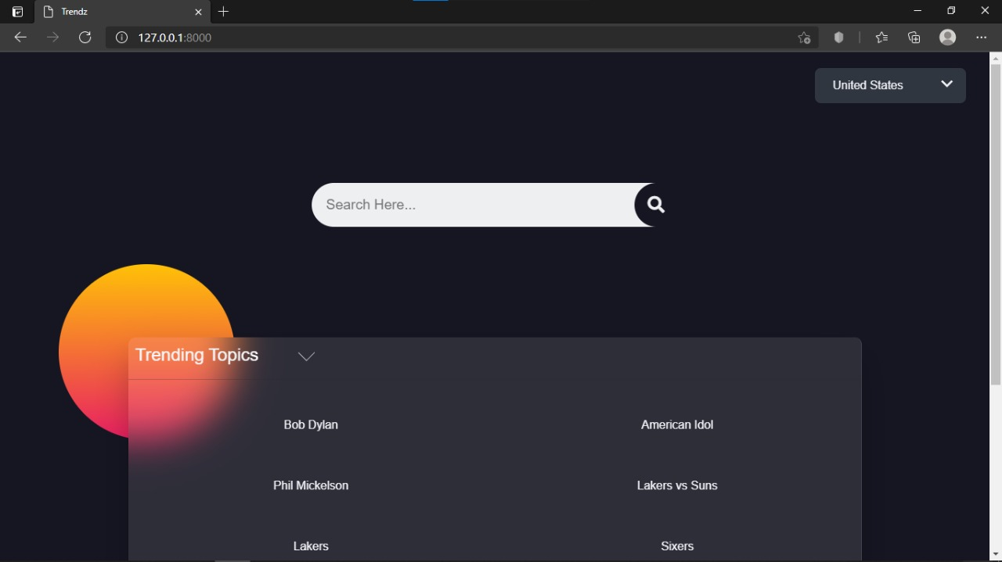**Output**

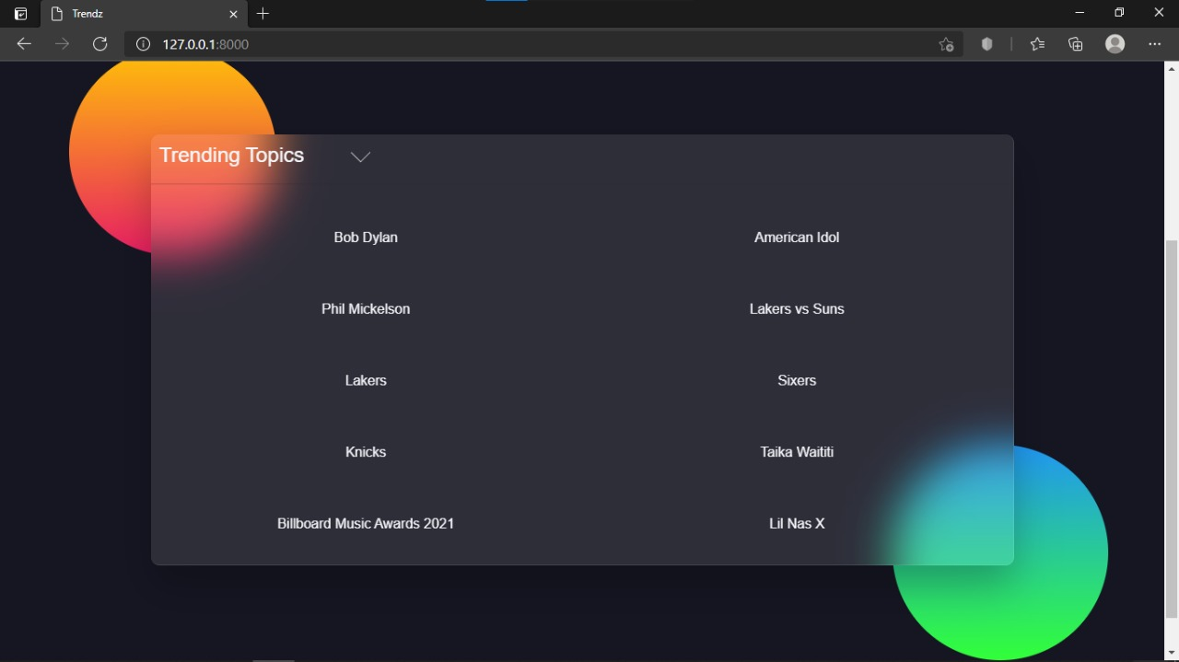

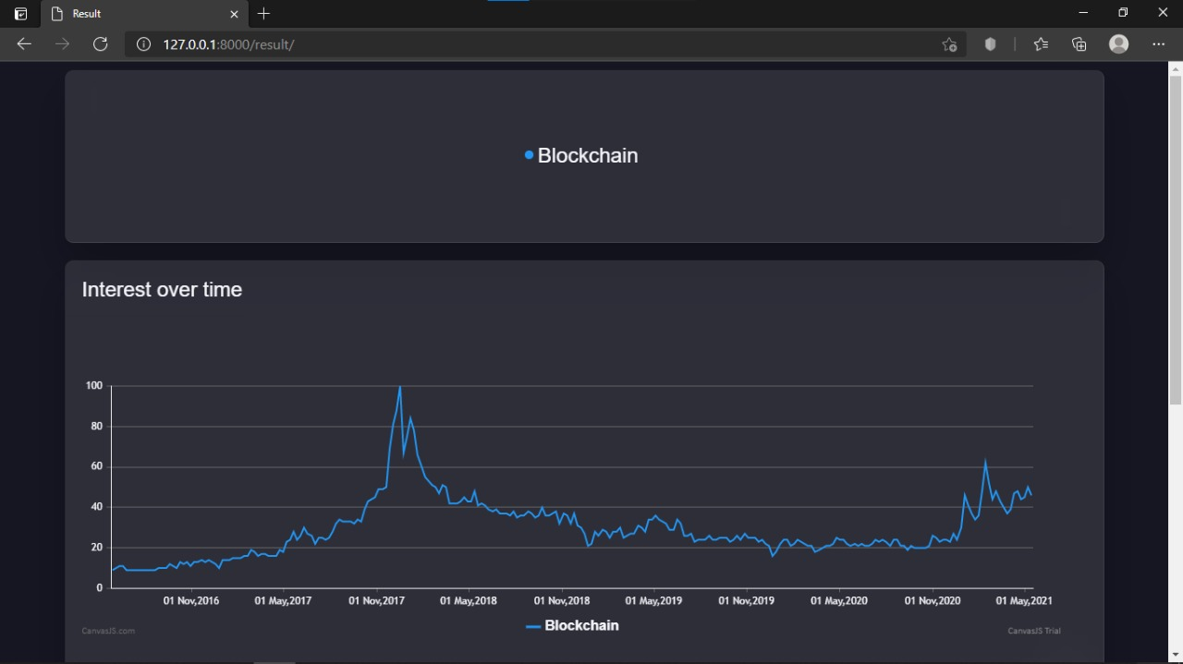

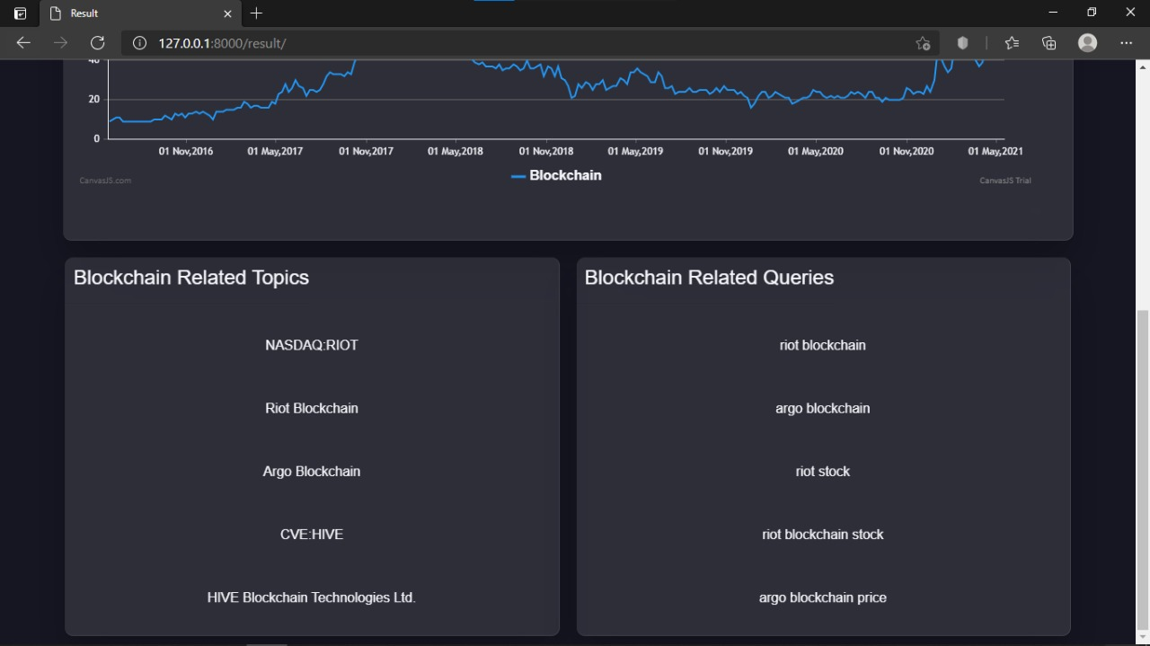

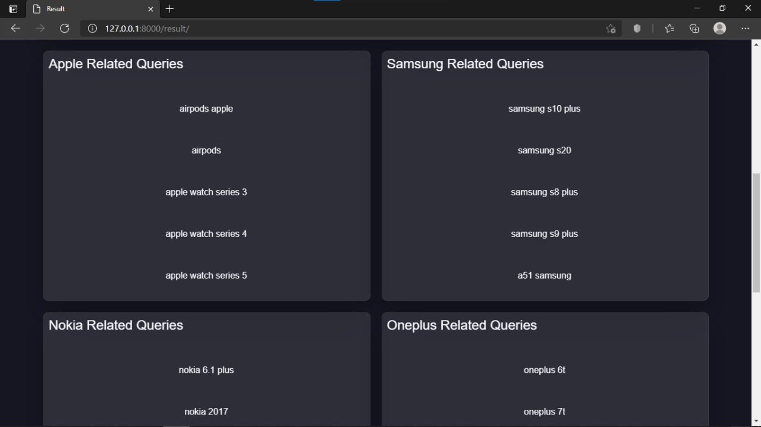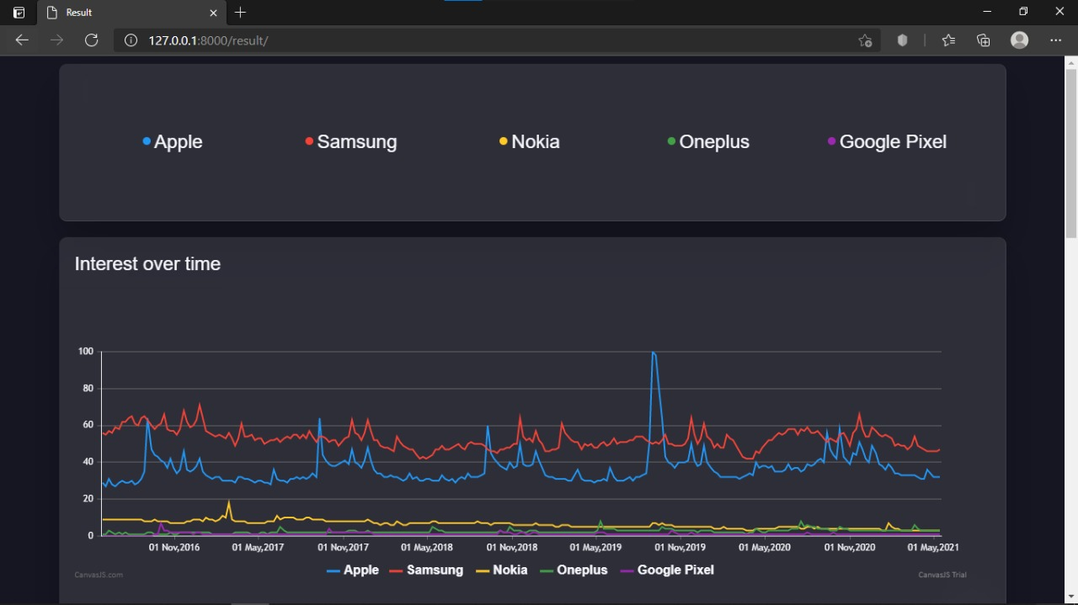

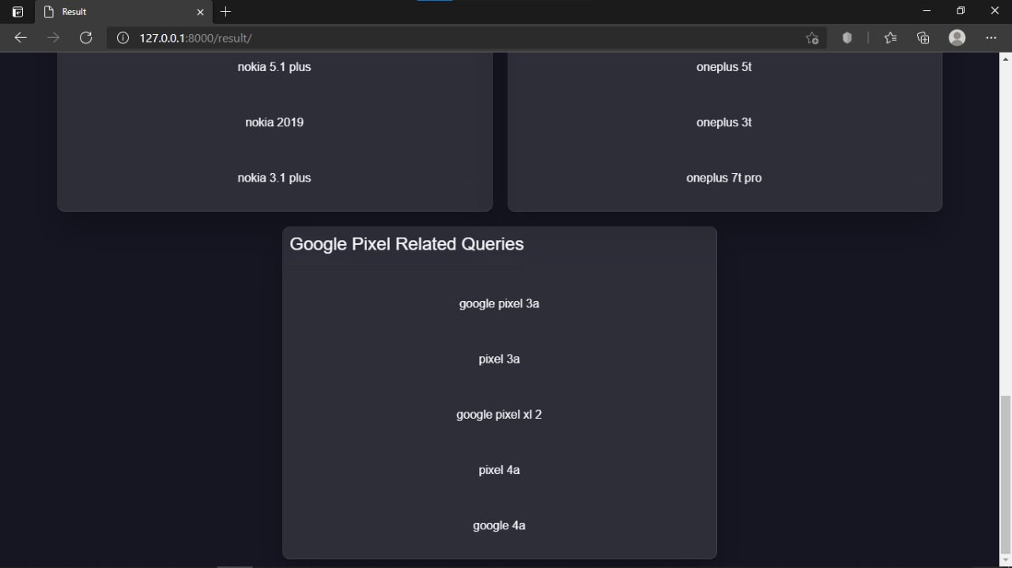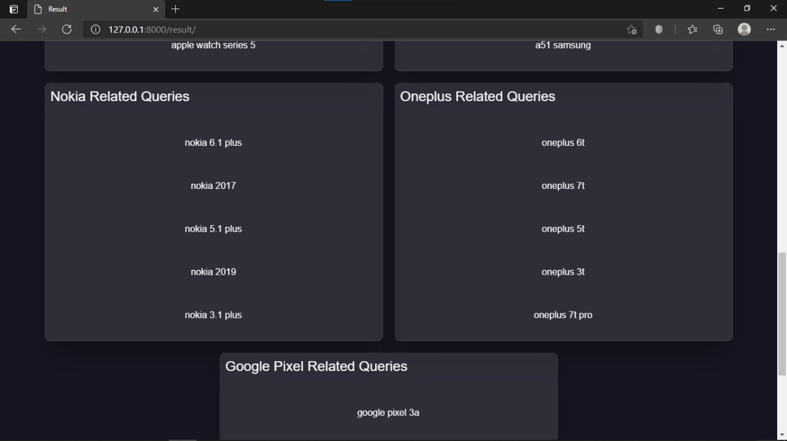

**References**

We do have used a few references during the process of building our project. The references used are from Websites, Books etc.

The references used are:

* **Websites:**

1: www.python.org

2: [www.en.wikipedia.org](http://www.en.wikipedia.org/wiki/Operating)

3: wwwprogramiz.com.

* **Reference Books:**

1: A Byte of Python

2: Learning with Python

**Skill Developed/Learning Out of This Micro Project:**

* Since we worked in a group, we developed the skill of ‘TEAMWORK’ in us.
* We learnt to program in Python very well and used HTML and CSS.
* We learnt how trends can help an online store appear on more feeds and search results, increasing the number of people who see it's posts and profiles.